Working Paper

What effects Weight and Waist the most: Using Linear Regression to Find the Best Predictor

By William Chaudoin

For years I’ve had trouble with my Weight and my Waist size. I’ve underwent diets and strict gym regiments. I’ve accomplished many personal goals doing this, but it was always way more difficult than I desired it to be. Along the way I decided to keep track of my body weight and waist size along with what I consumed daily. That way I could try to track any patterns and then replicate them if they worked.

Meanwhile I found myself lacking confidence in my ability to code and perform statistical analysis. I wanted to refresh these skills and build an extensive portfolio using a variety of programs and languages. I decided to use random datasets and some I had a personal connection to. Believing that doing an analysis on a dataset that I was familiar with would help determine if I truly understood how to interpret and perform basic and advanced statistics or modeling.

I felt the best way to finish the creation of a portfolio was to use this tracked biomedical and dietary data that I routinely use in my study. To start with the raw data and go all the way through the process of creating multiple models, finding errors, seeking solutions, and just challenging myself to find if there were any answers.

This paper is not an academic paper seeking to be peer reviewed, it is solely evidence of my ability and skillset in this field but above all a personal challenge to myself. To make it more difficult for myself, I did not conduct this study with only one platform. This analysis was performed using Python within Jupyter Notebooks but also using R within the R Classic environment. For the linear models only, I also performed this analysis using Excel. The results for all three platforms are featured throughout and in the appendix.

Starting this study, I did not know exactly what I would find nor was I entirely sure I was using the correct variables. However, that was by design. To truly understand a topic, one must be able to identify where they went wrong along the way. The end goal for this project is to go as far as the data will allow or that I am able.

**Data**

I collected 226 observations for 26 different variables. All quantitative variables include Weight in Pounds, Waist in Inches, Neck in Inches, Systolic Pressure in the Morning and at Night, Diastolic Pressure in the Morning and at Night, Body Temperature in the Morning and at Night, Pulse in the Morning and at Night, the amount of consumed Calories and Fat Calories per day, the amount of consumed grams of Fat, Sugar, Protein, and Fiber per day, and the total servings consumed per day.

Beyond these there are two qualitative variables measuring gym attendance and if cardio was performed, along with a Date variable. 4 remaining variables are Body Mass Index (BMI) calculated per day, a US Navy health metric called the Circumference Body Fat Index (CBF), the numbers of hours of Sleep per day, and the total intake in liters of Water per day.

I utilize all variables but Date in this study, thus using 25 of the 26 potential variables. They are all rounded to two decimal place whole numbers. Any missing values were replaced by the mean of that variable; Gym and Cardio are coded as dummy variables.

All values are observational data and not used for an experiment. A random sample from the overall sample was not taken, instead choosing to use all the data to train the models.

**Methodology**

48 ordinary least squares linear regression models were formed using the 25 variables at my disposal with each variable being used to predict Weight and then used to predict Waist. This resulted in having 24 models predicting Weight and 24 models predicting Waist. $$Y= β0 + β1X1+ε$$

The purpose of these models was to find the most statistically significant relationship for Weight and Waist. To discover if one variable has more predictive power than the other.

Several graphs were formed to look at the data on its own and as a relationship with each variable. To judge the performance of each model, I tracked the R-Squared, t-statistic, Pearson’s r value, and Coefficient of Variation (COV).

**Analysis**

Histograms for each variable were made to see how the data skews and to look at its distribution. These are in the Appendix: Graphs section. Weight, Waist, Morning Pulse, Night Diastolic Pressure, BMI, CBF, Calories, Carbs, Fat, Protein, Fiber, Sugar, Servings, Water intake, and Fat Calories all skewed right. Morning Diastolic Pressure skewed left. Morning Systolic Pressure, Morning Body Temperature, Night Body Temperature, Night Systolic Pressure, Sleep, Neck, Gym, and Cardio all showed no signs of skewedness.

Descriptive Statistics were calculated for variables involved, which were used to calculate various test statistics and a 95% confidence interval for the mean. These are listed below and in the Appendix: Table 1. A hypothesis test was performed to determine if the Mode of each variable was the true mean. Weight, Neck, Morning Body Temperature, Morning Systolic Pressure, Morning Diastolic Pressure, Morning Pulse, Night Systolic Pressure, Night Diastolic Pressure, BMI, CBF, Gym, and Cardio all rejected the null hypothesis that true Mean is the Mode. Meanwhile, Waist, Night Body Temperature, Night Pulse, Sleep, Calories, Carbs, Fat, Protein, Fiber, Sugar, Servings, Water intake, and Fat Calories all failed to reject the null hypothesis that the true Mean is the Mode.

Based on the Descriptive Statistics, my Weight and Waist are above average and within the Class 2 Obesity range as determined by the Center for Disease Control and Prevention. Unsurprisingly my BMI also falls within this same range. The Navy CBF is beyond the maximum allowed of 26 for males. My Calorie consumption is beyond the maximum 2500 for a male. Carbs, Sugars, and Fat Calories is excessive. Water intake is too low at only 1 liter. Protein and Fiber could be increased. Morning and Night Body Temperature and Pulse are within normal ranges. Morning and Night Systolic Pressure is elevated and within the Stage 1 Hypertension range, while Morning and Night Diastolic Pressure are elevated but within the normal range of below 80. Sleep is roughly 8 hours which is normal.

**Descriptive Statistics Table**

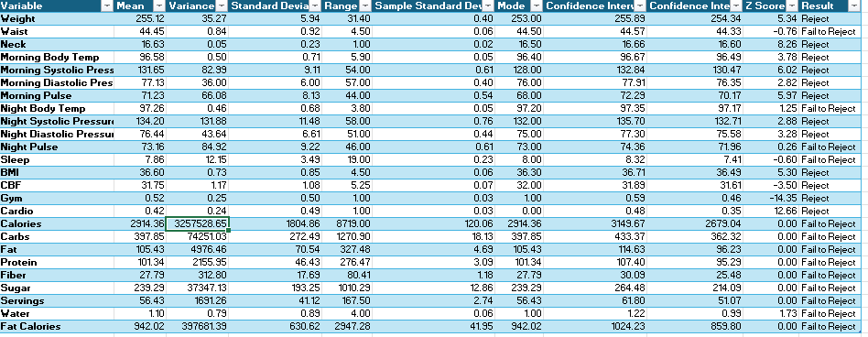

We can be 95% confident that the true mean for Weight is between 254.34 and 255.89 pounds, while we can be 95% confident that the true mean for Waist is between 44.33 and 44.57 inches. For Neck, we can be 95% confident that the true mean is between 16.60 and 16.66 inches. The true mean for Morning Body Temperature is between 96.49 and 96.67 degrees. Regarding morning blood pressure, we can be 95% confident that the true mean for Systolic Pressure is between 130.46 and 132.85, while Diastolic Pressure is between 76.34 and 77.91. We can be 95% confident that the true mean for Morning Pulse is between 70.17 and 72.30; the Night Body Temperature true mean is between 97.17 and 97.35. For night blood pressure, the true mean for Systolic Pressure is between 132.70 and 135.70, while the true mean for Diastolic Pressure is between 75.58 and 77.31. We can be 95% confident that the true mean for Night Pulse is between 71.96 and 74.36. As for Sleep, BMI, and CBF, we can be 95% confident the true mean is between 7.41 and 8.32, 36.49 and 36.71, and 31.61 and 31.89. Since Gym and Cardio are binary variables, their 95% confidence intervals are less than 1 with Gym between .46 and .59 while Cardio is between .35 and .48. We are 95% confident that the true mean for Calories is between 2678.52 and 3150.19; while Fat Calories is between 859.62 and 1024.42. The true mean in grams for Fat, Protein, Fiber, and Sugar is between 96.21 and 114.65, 95.28 and 107.41, 25.47 and 30.10, and 214.04 and 264.54. We are 95% confident that the true mean value for Servings is between 51.06 and 61.81, while the true mean value for Water intake is between .99 and 1.22.

**Models**

The equations for all models can be viewed below and as Table 2 in the Appendix.

**All Models Table**

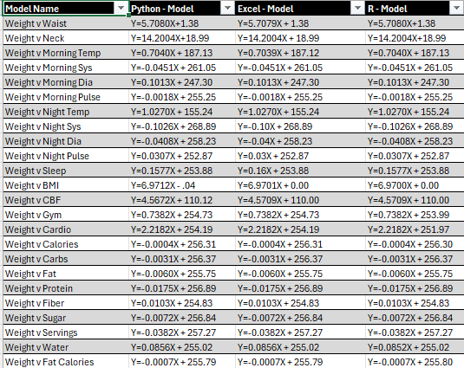

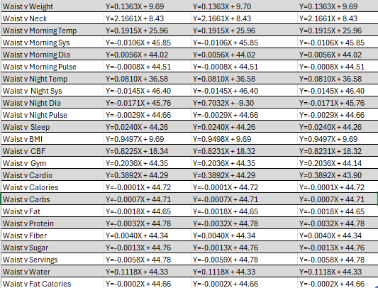

For the first 24 models in which Weight is used as the dependent variable, the highest R-Squared was associated with BMI at 1 which can be found in Table 3 in the Appendix. This is not surprising as BMI is calculated with Weight, and they are highly correlated as Pearson’s r is 1. The t-statistic associated with BMI is statistically significant and the model has a low Coefficient of Variation (COV) attached is below 10, suggesting a low standard deviation

Waist is the next best performing model with an R-Squared of .7778, a statistically significant t-statistic, a high correlation of .8819, and a low COV of 1.1022. The results of this model are not surprising as the higher a person weighs, the more mass they gain holding density constant and thus their waist should reflect that.

CBF is the next best predictor which is surprising as Weight is not used to calculate it, just Neck, Height, and Waist. However, there is correlation between Waist and Weight so that should explain part of the variation. This model has an R-Squared of .6921, a COV of 1.2975, an r of .8319, and a statistically significant t-value.

Using Neck to predict Weight resulted in an R-Squared of .3107 and a still strong positive correlation of .5574. The t-value is still significant and the COV remains below 10 with 1.9412.

Oddly the arbitrary variable Servings has the next best R-Squared though it is very low with .0701and a negative correlation of -.2647. While the t-statistic is significant and the COV is below 10 with 2.2547 the predicting power of this model seems low. The underlining variable has no true meaning and can’t be used to reliably predict Weight since the values can’t be replicated reliably. Only 7% of the variability in Weight is explained by this model despite it being statistically significant and the correlation is near zero.

As for Sugar, it has an R-Squared of .0547, a negative correlation of -.2340, a low COV of 2.2732, and a significant t-value. Night Systolic Pressure has an R-Squared of .0394, a COV of 2.2916, a significant t-statistic, a negative correlation closer to zero than any previous with -.1985.

The Cardio model has a .0339 R-Squared, a significant t-value, a slightly positive correlation of .1841, and a COV of 2.2982. For the Carbs model, it has a negative correlation of -.1444, an R-Squared of .0208, a significant t-value, and COV of 2.3136.

The final model that was statistically significant in predicting Weight was Protein. It has an R-Squared of .0187, a significant t-value, a negative correlation of -.1366, and a COV of 2.3162. All remaining models presented lower R-Squared values, not statistically significant t-values, and worse correlation values. This includes variables that I would expect to have a statistically significant relationship like Calories, Sleep, Gym attendance, and Water intake.

Several models showed statistically significant relationships with Waist, albeit more than Weight. Like Weight, such variables as CBF, BMI, Neck, Sugar, Servings, Cardio, Night Systolic Pressure, and Protein were found to have a statistically significant relationship with Waist. There were also some with significant t-values that did not meet the mark when they regressed against Weight. These variables are Calories, Fat Calories, Morning Body Temperature, and Fat.

The CBF model had the highest R-Squared with .9403 of any of the models regressed against Waist. This isn’t surprising as Waist is used to calculate the CBF statistic. We should also expect to see a high correlation between the two variables; we do with a Pearson’s r of .9697. The t-value for this model was statistically significant and the COV value was deeply below 10 at .5067.

In a reverse of previously discussed model, instead of Weight being regressed against Waist, I regressed Waist against Weight. Overall, the same result was found with an R-Squared of .7778, a statistically significant t-statistic, and a high positive correlation of .8819. One odd difference between the two models was the COV is lower for this model than the previous, with a score of .9773; slightly less than the 1.1022 of the previous.

BMI has a statistically significant relationship with Waist despite the statistic not including it in the BMI calculation. Its R-Squared is .7775 with a statistically significant t-value, a COV of .9780, and a correlation of .8817.

Regressing Waist onto Neck gave an R-Squared of .3028, a statistically significant t-value, a COV of 1.7311, and a correlation of .5503.

Sugar performed better with Waist than with Weight as it produced a larger statistically significant t-value and a higher R-Squared of .0740. It also has a lower COV of 1.9950 and roughly the same correlation of -.2720.

Meanwhile, Servings performed worse with Waist than with Weight as this model has a lower R-Squared of .0683, a smaller but still statistically significant t-value, and roughly the same correlation of -.2614. However, a COV of 2.0011 is lower with this model.

The model using Cardio was the seventh best performing with Waist as a Dependent Variable. It has an R-Squared of .0437, a statistically significant t-value, a correlation of .2091, and a COV of 2.0274.

Carbs has a negative correlation with Waist as its Pearson’s r value is -.1945. Not a strong negative relationship but barely a relationship at all. Its model has an R-Squared of .0378, a statistically significant t-statistic, and a COV of 2.0336.

The R-Squared for the Night Systolic Pressure model is .0331. It also had a statistically significant t-value and a COV of 2.0386. It also had a negative correlation with -.1820.

Morning Temperature is barely statistically significant with Waist and had an R-Squared of .0220. Explaining barely 2% of the variability in Waist while having a correlation of slightly above zero with .1480. Its COV is slightly higher than other models with 2.503 but still well below 10.

Only 4 more models were statistically significant with Waist. Those regressed Waist against Calories, Protein, Fat Calories, and Fat. They all also have a negative relationship with Waist as they all have negative correlation scores. Calories has a Pearson’s r of -.1806, Protein has an r of -.1618, while Fat Calories scored a -.1486, and the Fat model has a value of -.1412. The R-Squared values for each don’t tell a very detailed picture either. The Calories model has an R-Squared of .0326 and a COV of 2.0391. The Protein model isn’t an improvement with an R-Squared of .0262 and a COV of 2.0459. While the Fat Calories model has an R-Squared of .0221 and a COV of 2.0502. Finally, the Fat model has an R-Squared of .0200 and a COV of 2.0524.

Beyond the test statistics and measurable values there are several issues with the coefficients of the models. Some models make sense as an equation while others have incorrect signs, or much of their predictive power is located within the intercept. BMI has the most predictive power based on coefficients but that’s due to the high correlation from using Weight to calculate it. Besides that, all Weight models derive most of their power from the intercept and little value from the variable coefficient. The Calories and like variables all have negative coefficients when predicting Weight. This makes no logical sense as it suggests eating more would make someone weigh less.

The above issues are also present in the Waist models but not to the same extent. A large amount of the predictive power is within the intercept term but not as wildly as with the Weight models. The Calories and like variables also have negative coefficients, which do not make logical sense as it means consuming more would make my Waist smaller.

**Conclusion**

After analyzing the results of all these models, I have come to the stark conclusion that these variables don’t really predict Weight or Waist too greatly on their own. R-Squared for most models is too low. Barely able to predict variability within double digits in few cases. Half of all models are statistically significant, leaving 24 models irrelevant. The COV for all models is well below the desired threshold of 10 but the correlation values leave something to be desired. Neck, Waist, Weight, BMI, and CBF are the only ones with high positive or negative relationships. There is an interconnected relationship between variables too. BMI and CBF are calculated using Waist and Weight so they don’t have any deeper value beyond the already existing variables. They suffer from severe multicollinearity. Weight, Waist, and Neck do as well but to a lesser extent.

The main issue comes from the consumption variables of Calories, Protein, Carbs, Fiber, Sugar, and Fat. With the negative coefficients I feel something is wrong and I’m considering that maybe I’m using the wrong dependent variable. Instead of predicting my overall Weight or Waist, I should be predicting the change in both variables. Daily consumption would have a larger role in the daily change rather than the long-term values. This is an idea I seek to explore in future studies.

The next step should be conducting multiple regression with variables that have some value and perhaps see if a combination of the consumption variables will provide better results. Beyond that, explore other types of models besides multiple regression such as quadratic and interaction models. If this path is fruitless then transforming the variables is the final idea currently.

**Appendix: Tables**

**Table 1: Descriptive Statistics**



**Table 2: All Models**



**Table 3: Model Test Statistics**

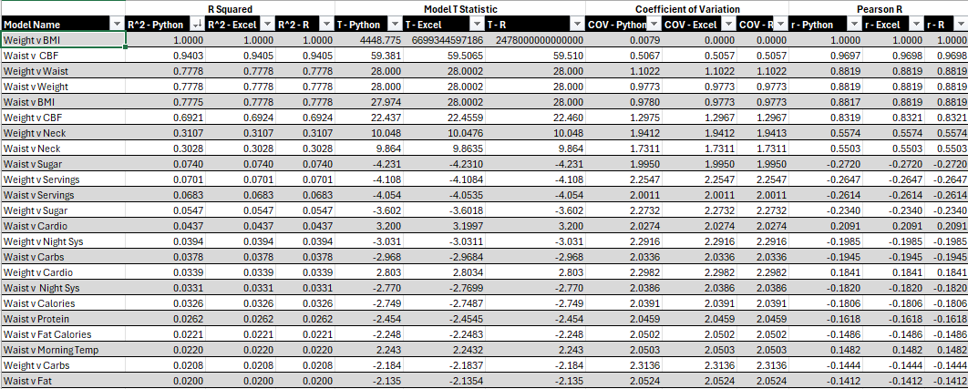

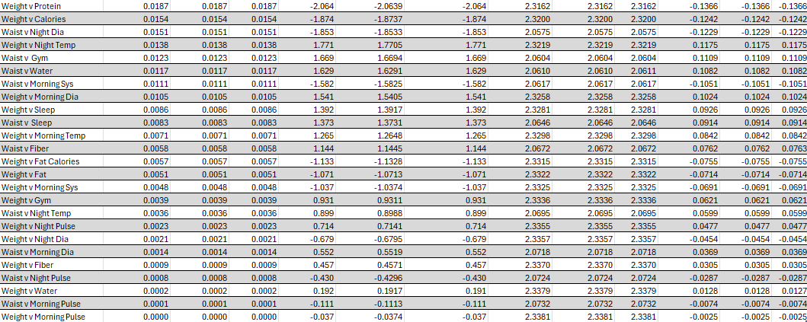

**Table 4: Confidence Intervals for Each Variable**

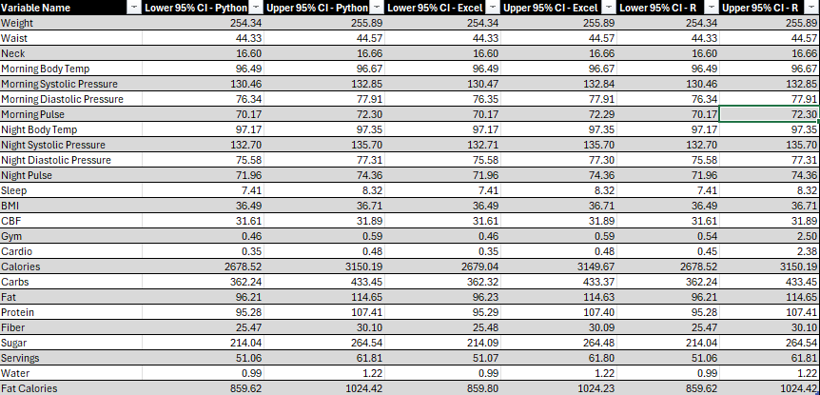

**Table 5: Z Test For Each Variable**

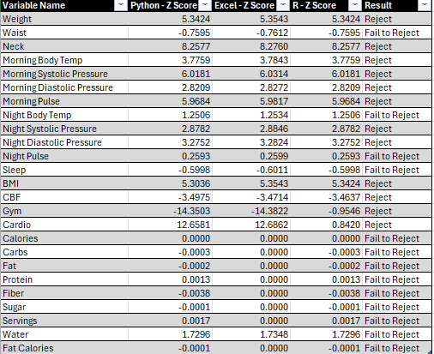

**Table 6: B1 Coefficient Confidence Intervals**

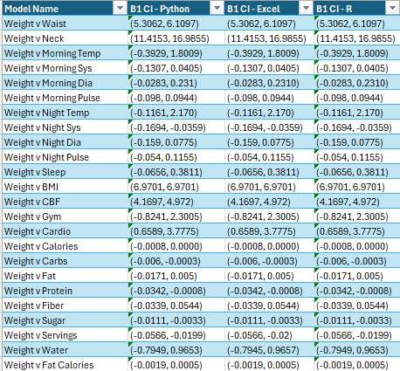

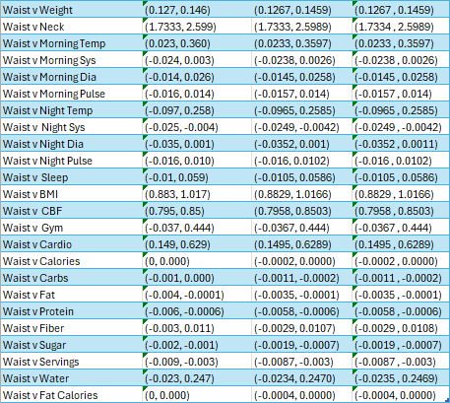

**Table 7: Error Statistics For Each Model**

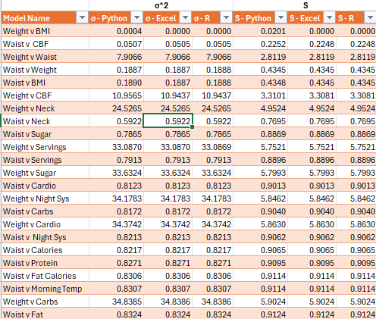

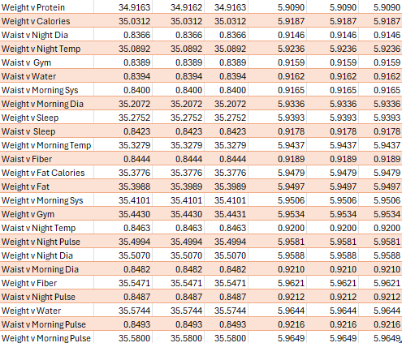

**Appendix: Graphs**

**Graphs 1: Histograms For All Variables (Excel)**

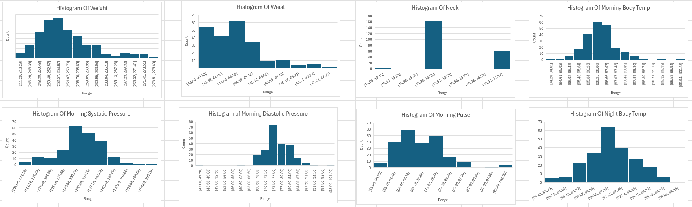

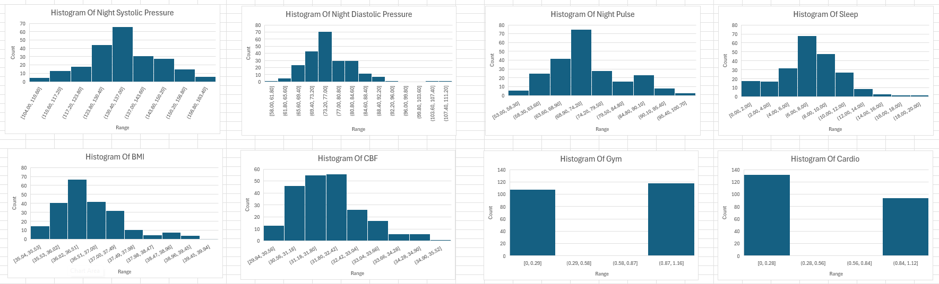

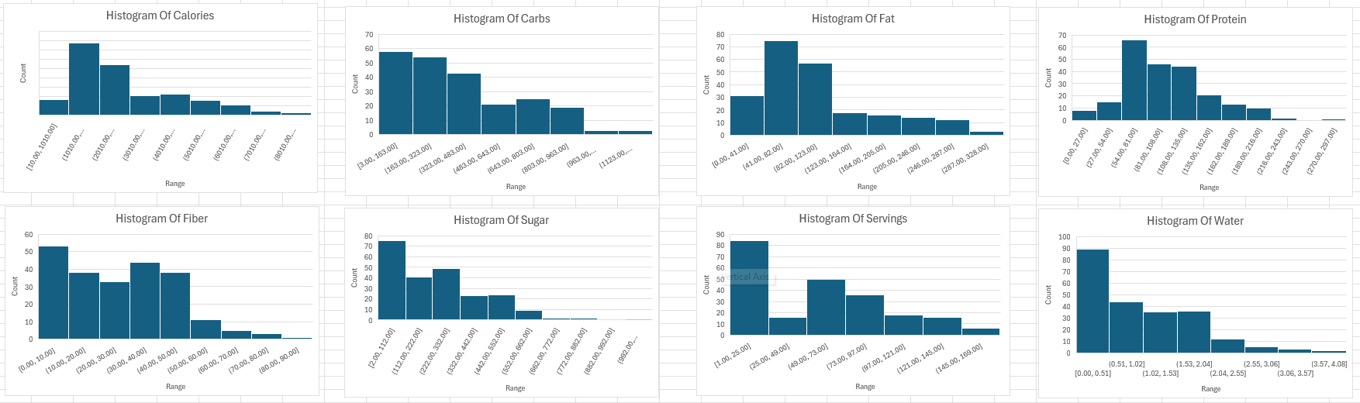

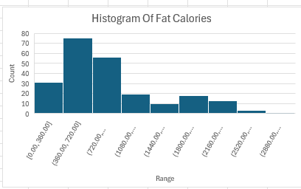

**Graphs 2: Weight Scatterplots With Regression Lines (Excel)**

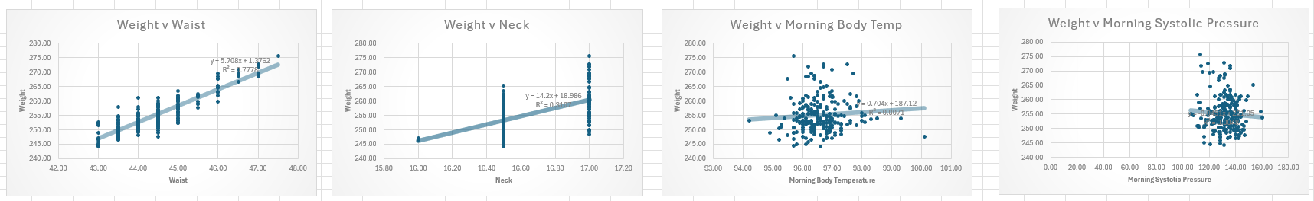

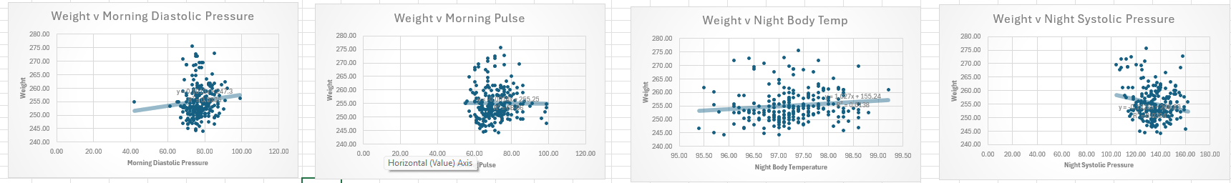

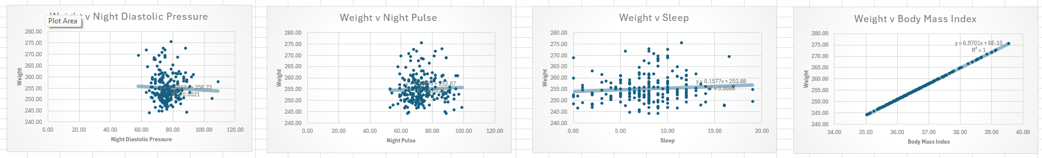

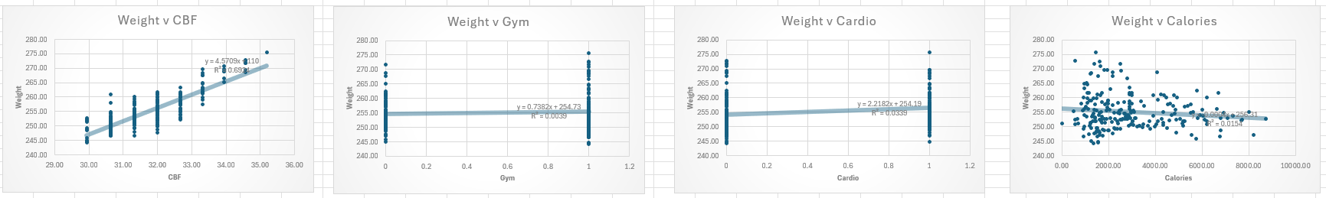

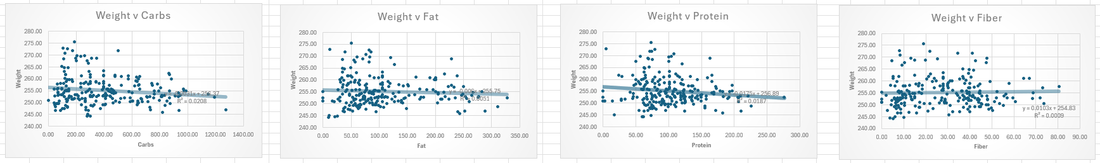

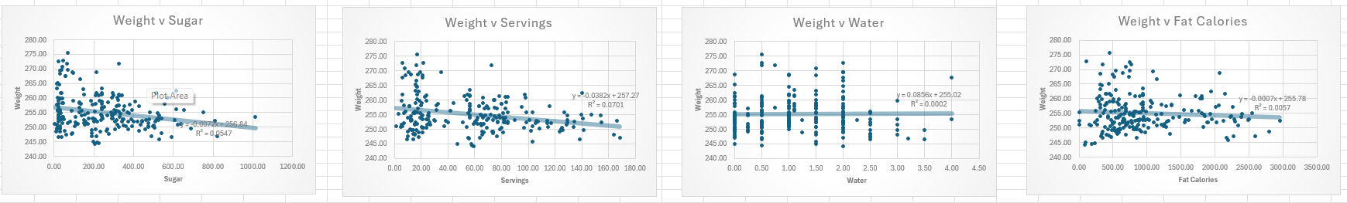

**Graphs 3: Waist Scatterplots With Regression Lines (Excel)**

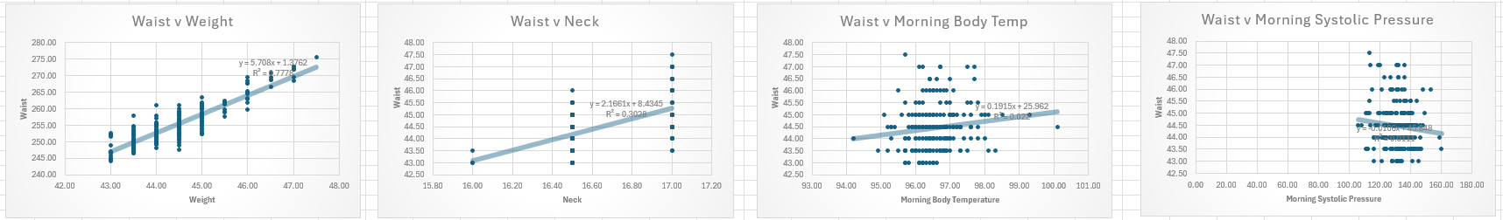

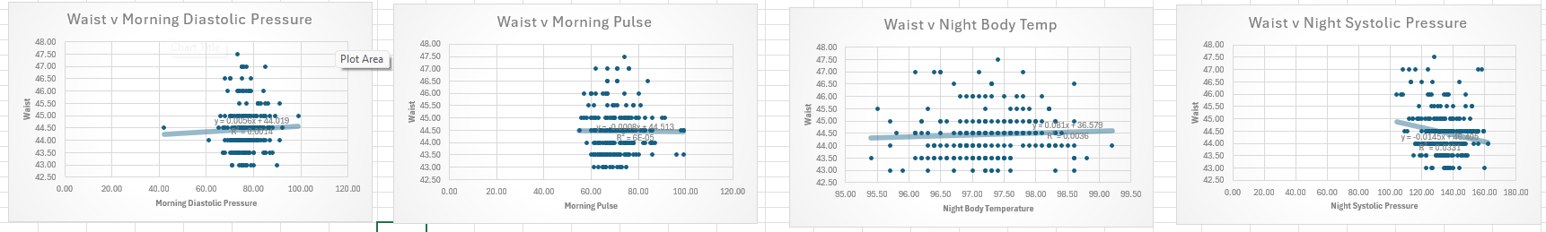

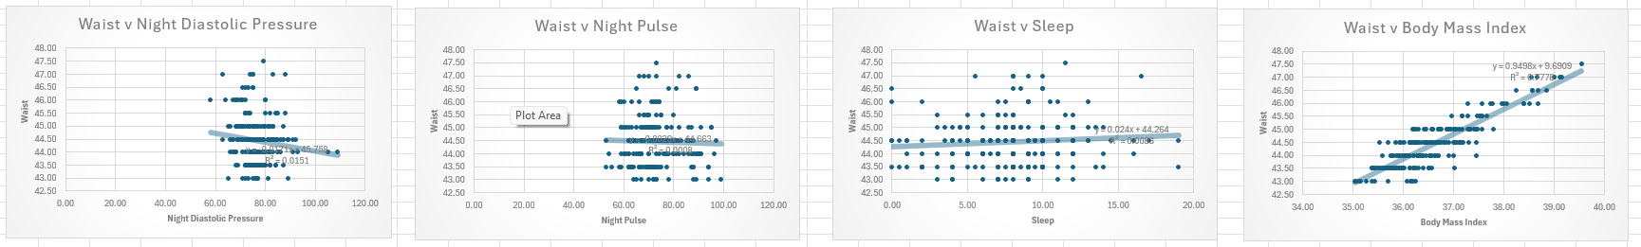

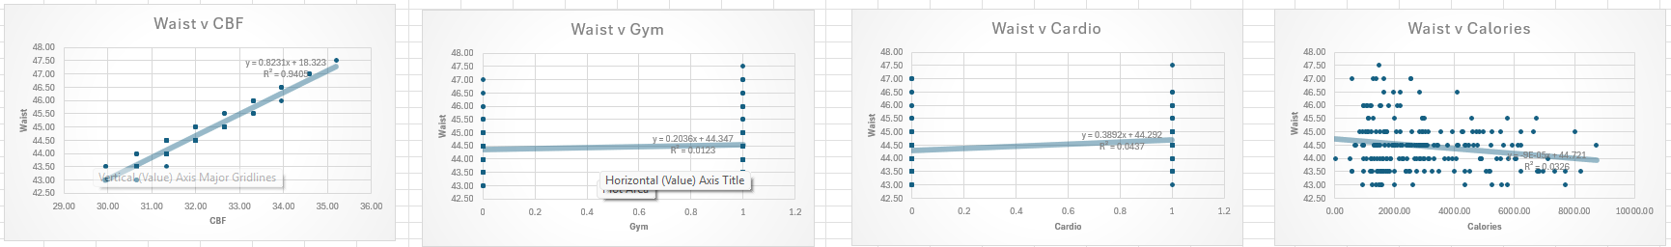

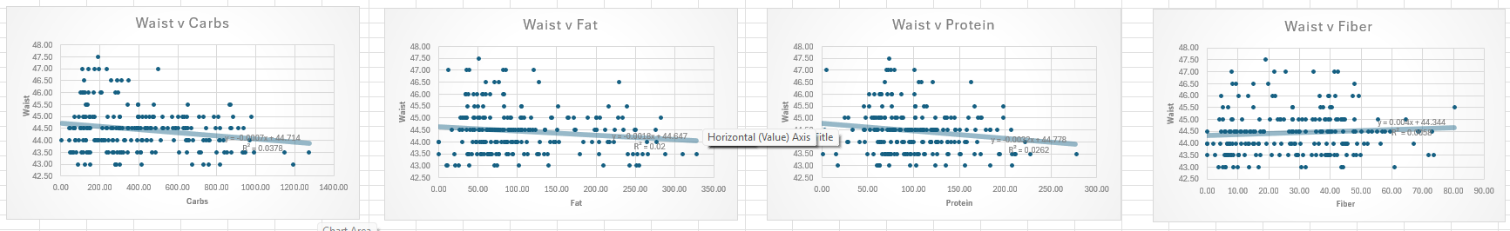

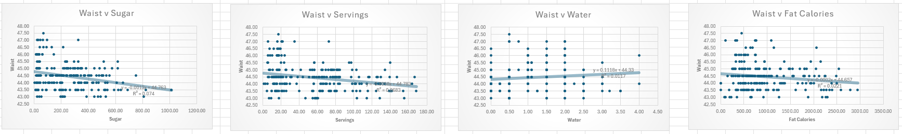

**Graphs 4: Weight Residual Plots (Excel)**

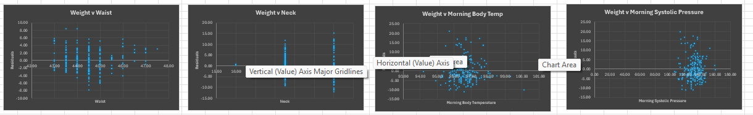

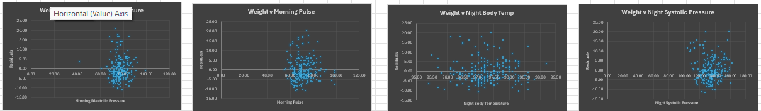

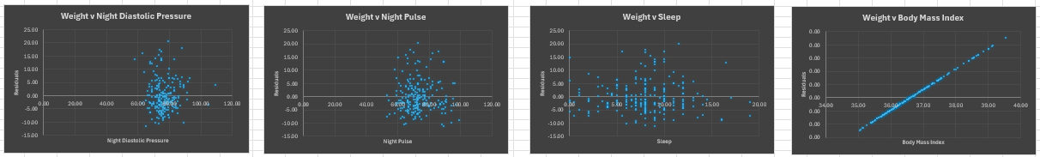

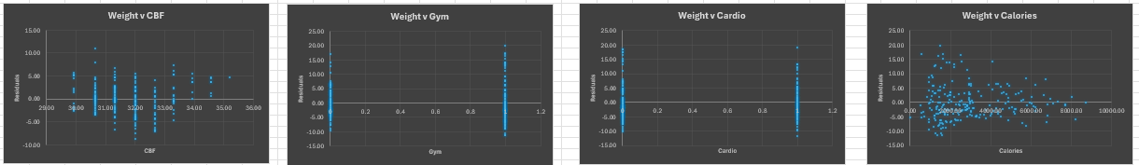

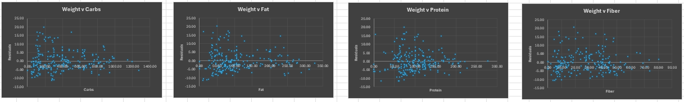

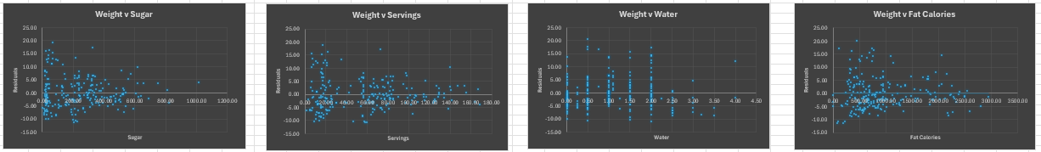

**Graphs 5: Waist Residual Plots (Excel)**

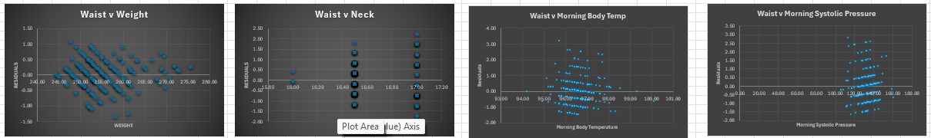

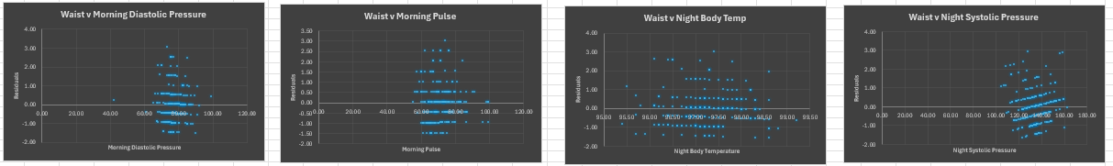

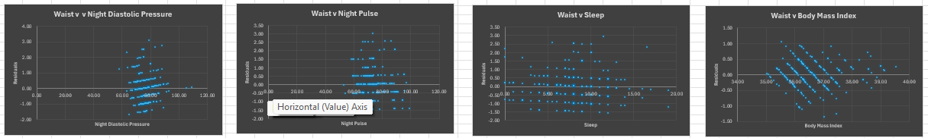

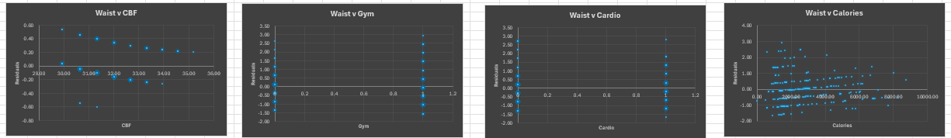

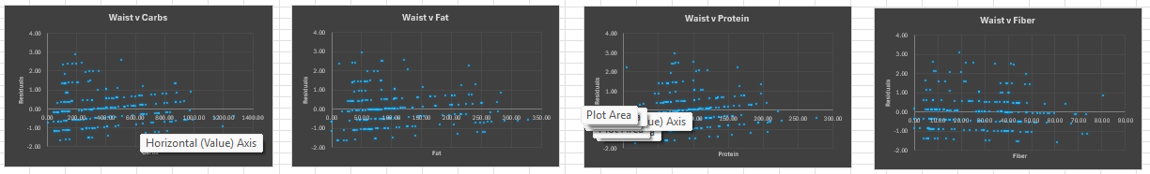

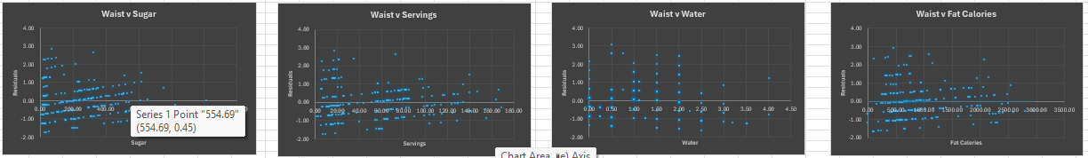

**Graphs 6: Python Histograms**

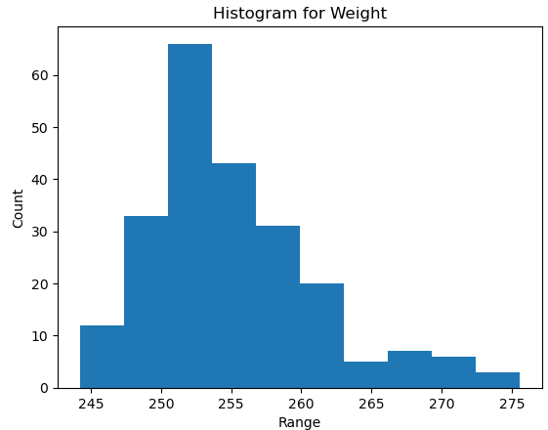

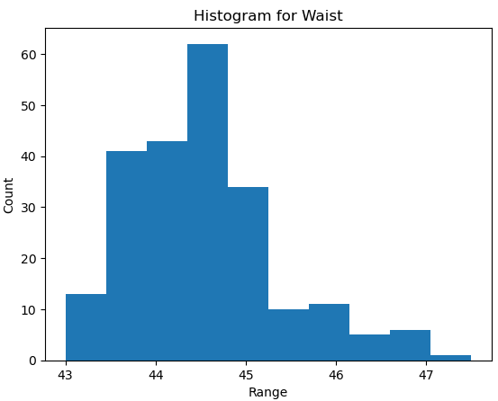

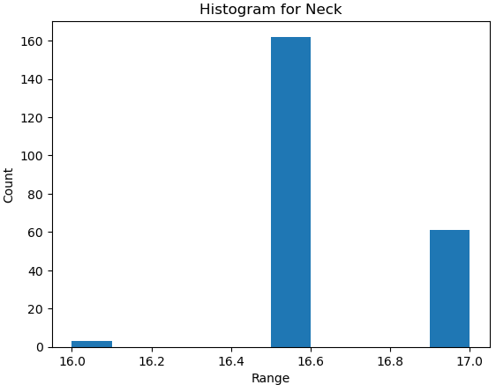

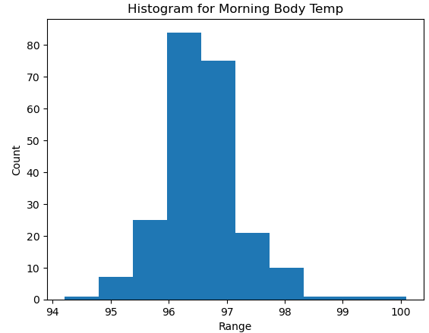

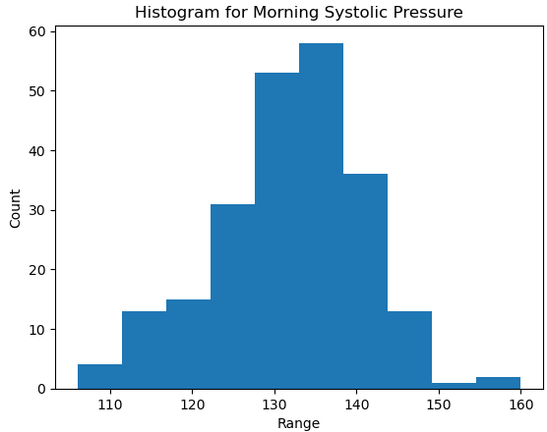

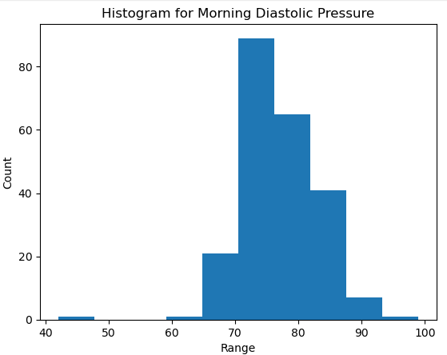

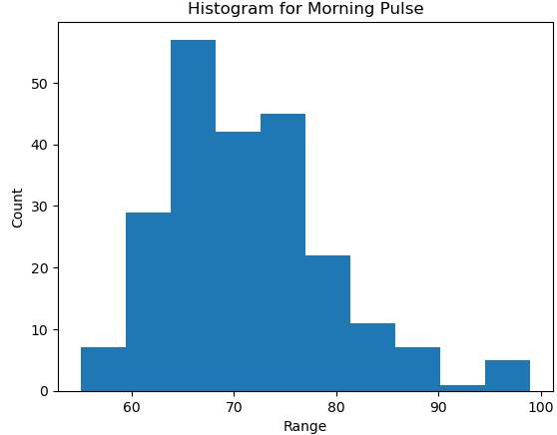

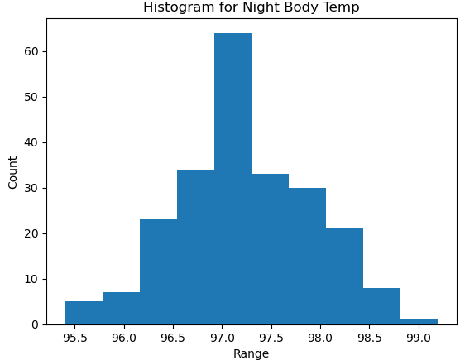

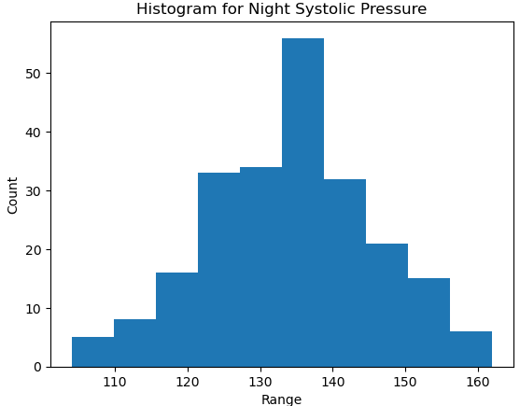

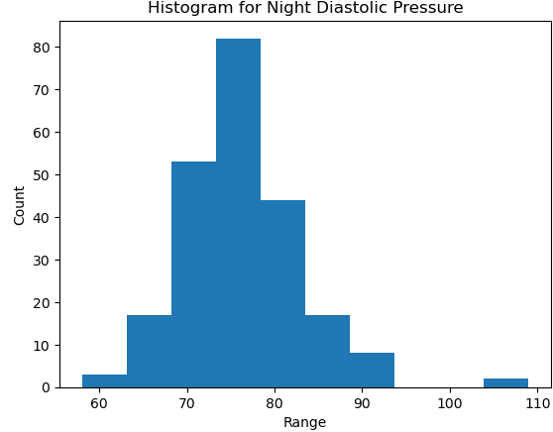

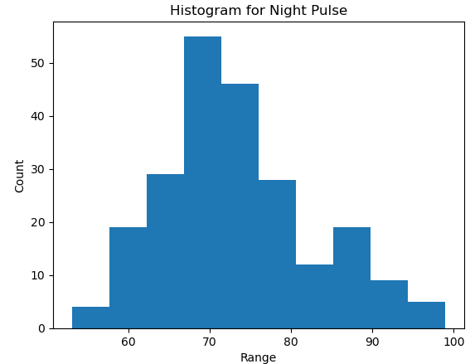

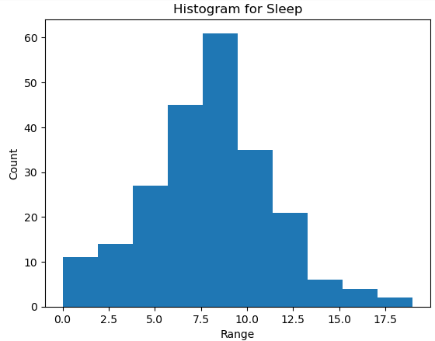

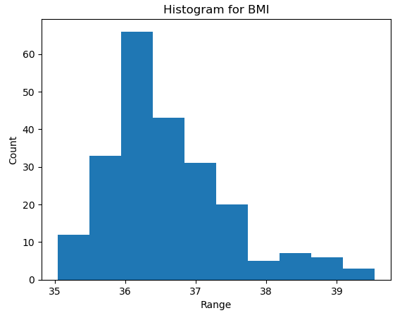

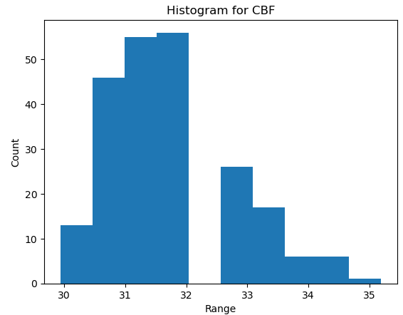

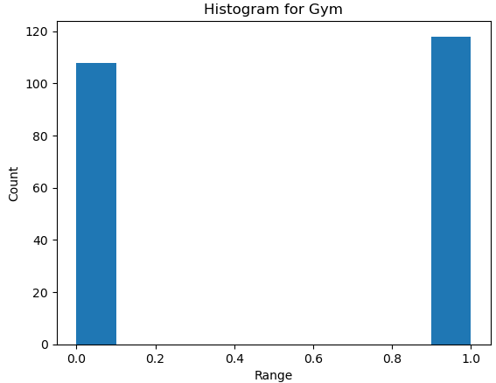

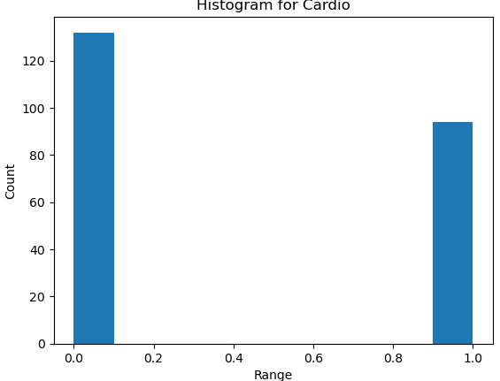

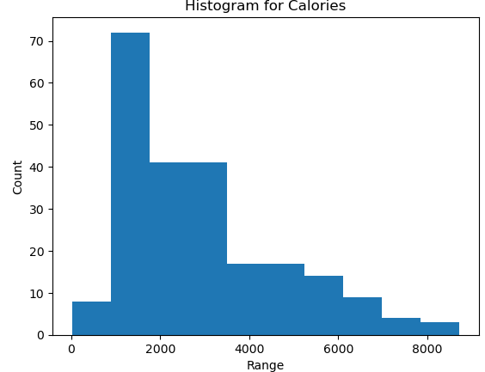

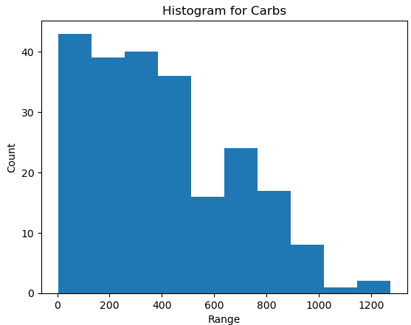

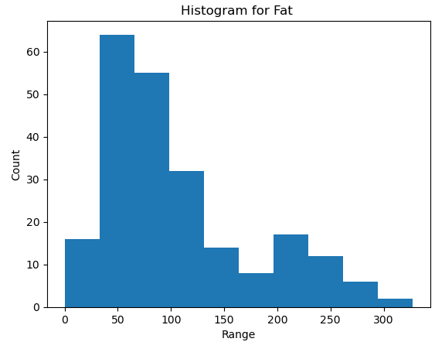

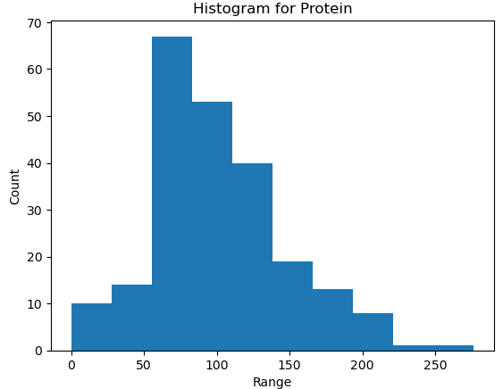

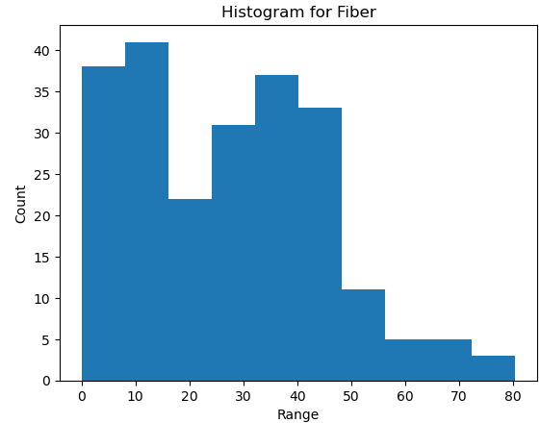

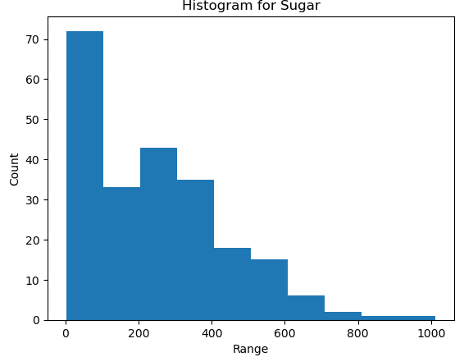

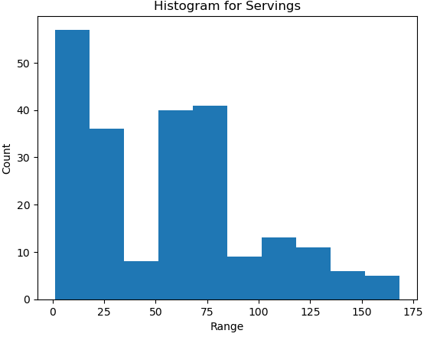

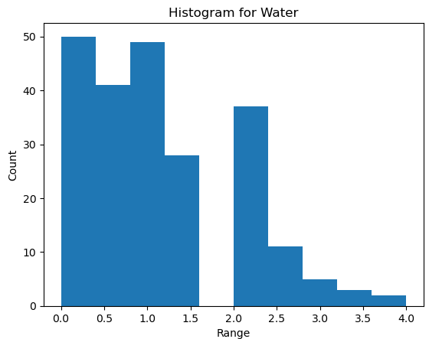

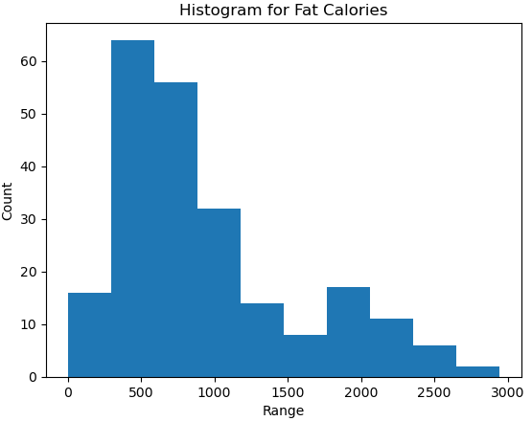

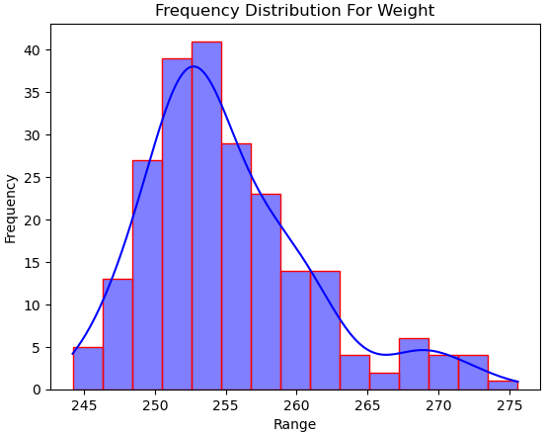

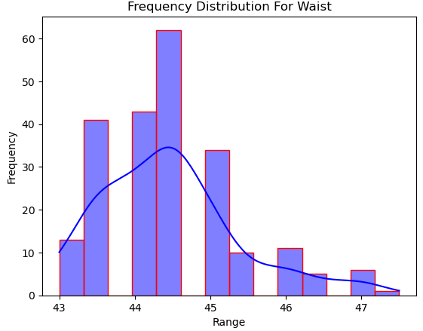

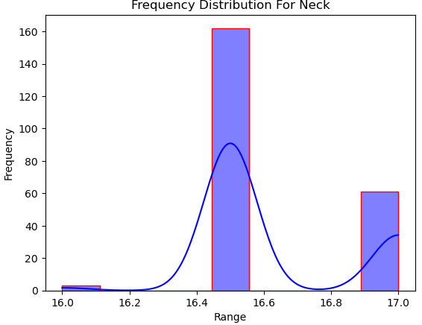

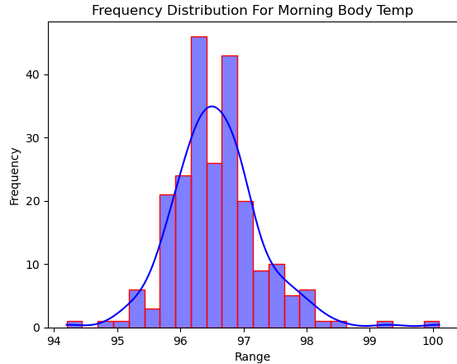

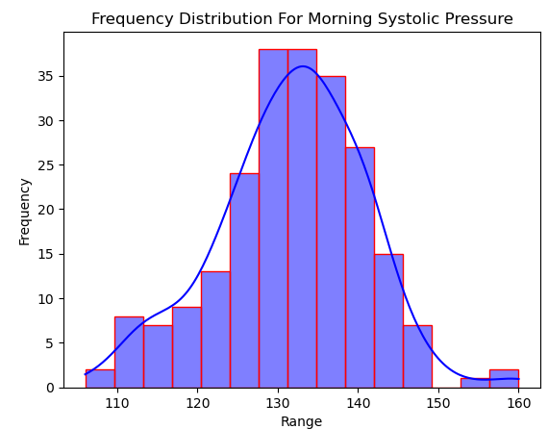

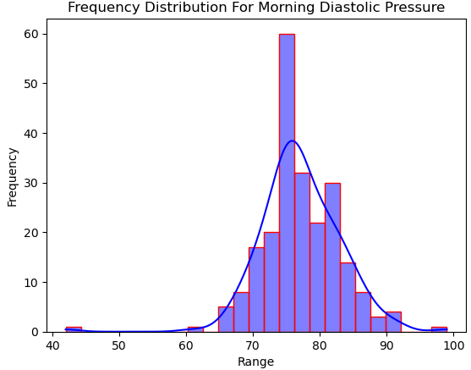

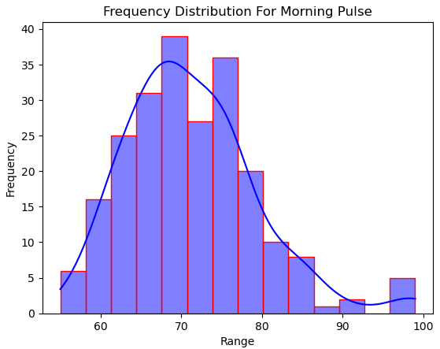

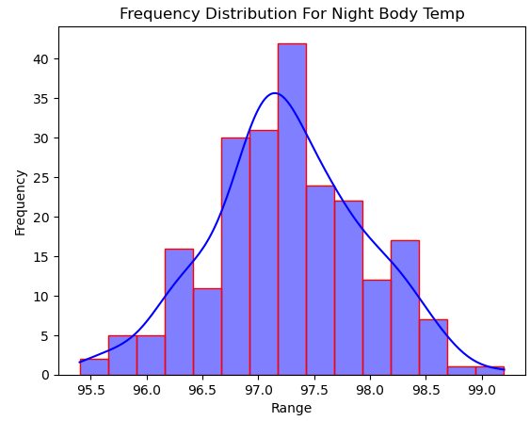

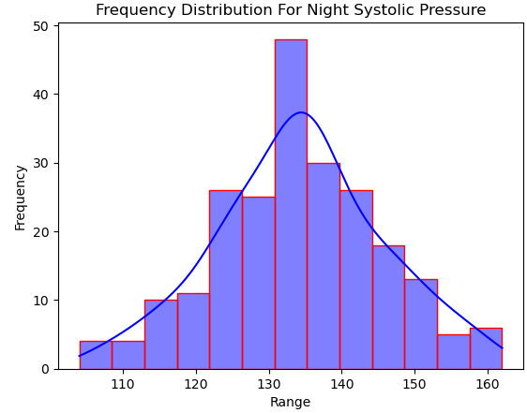

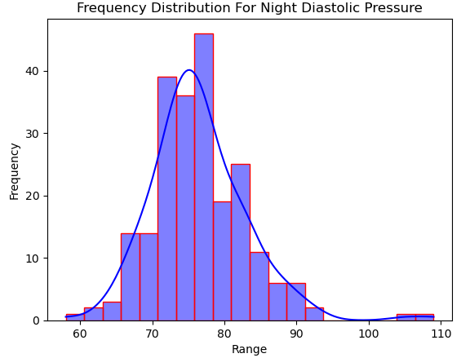

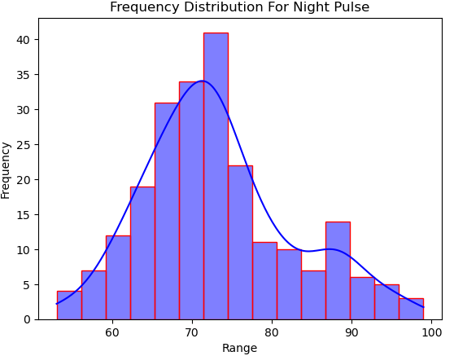

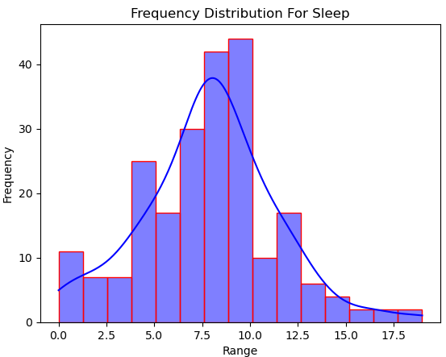

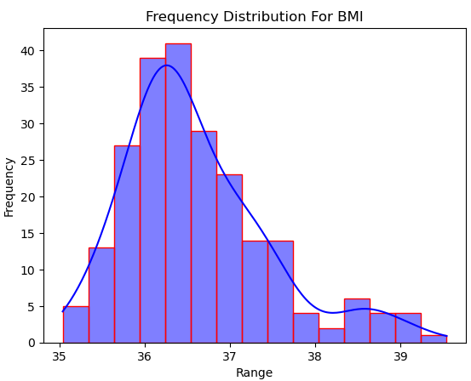

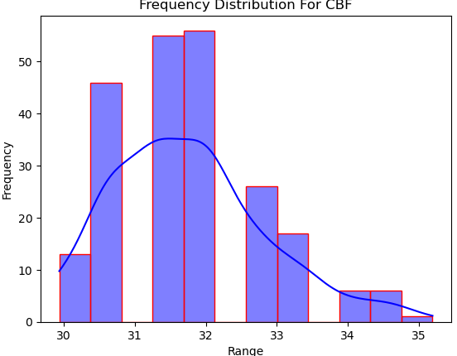

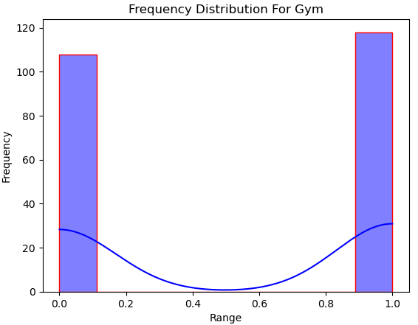

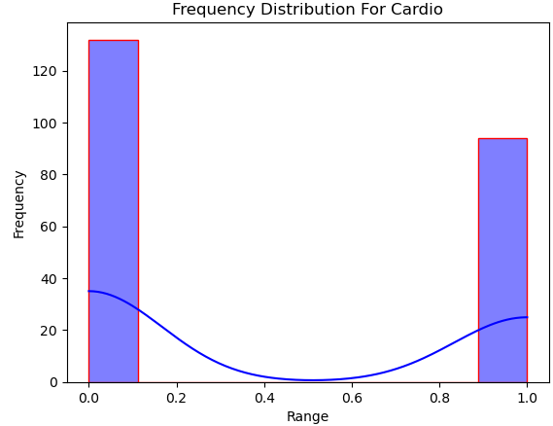

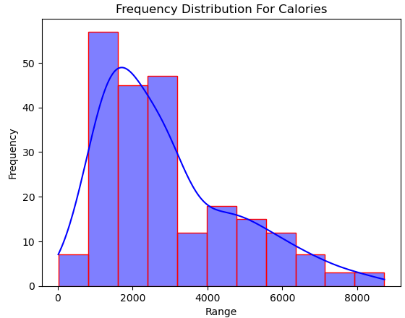

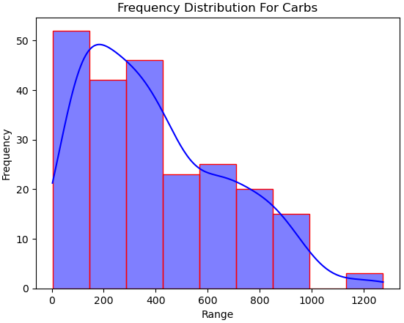

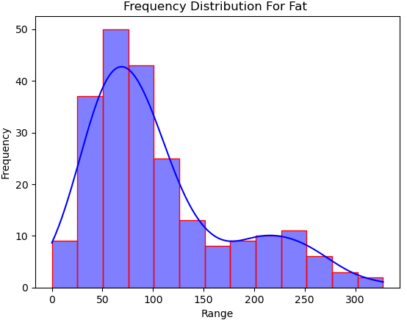

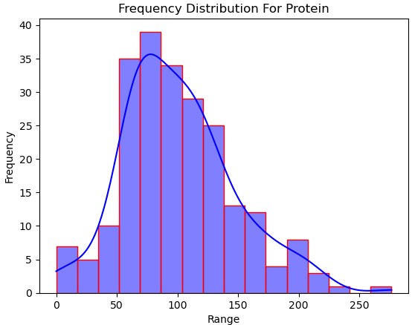

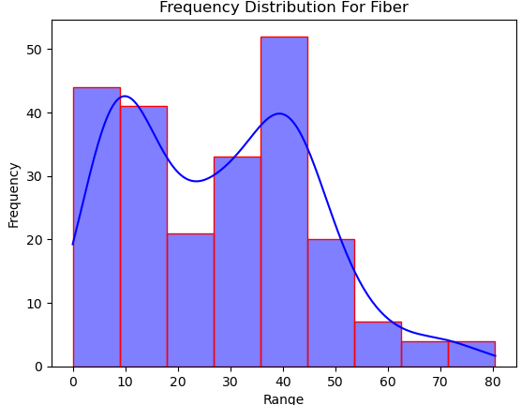

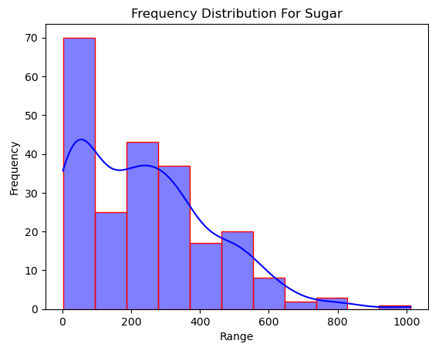

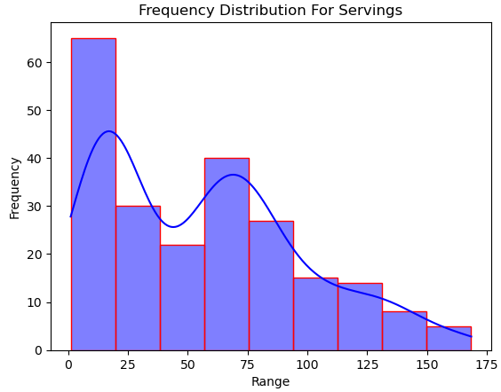

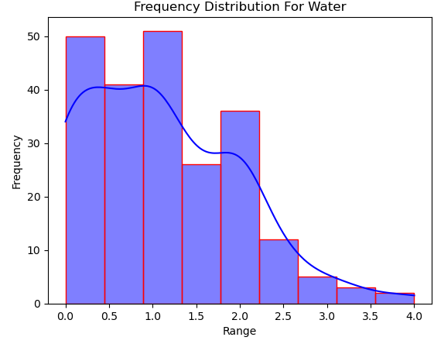

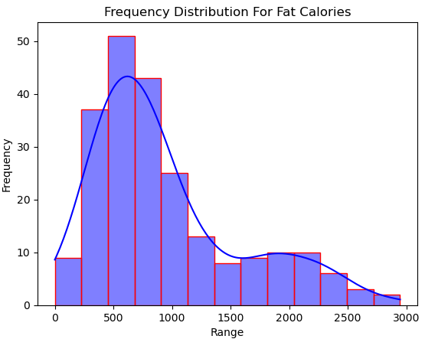

**Graphs 7: Weight Scatterplots With Regression Lines (Python)**

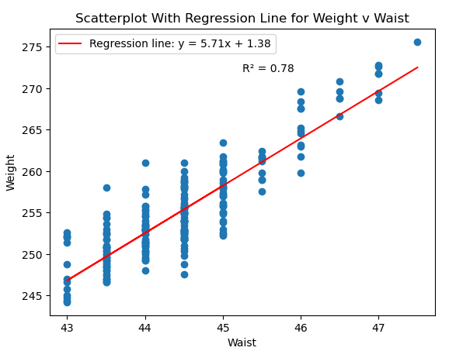

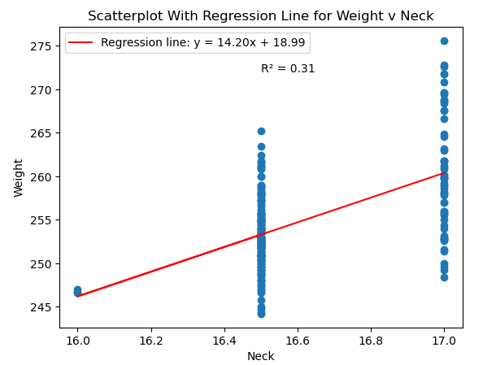

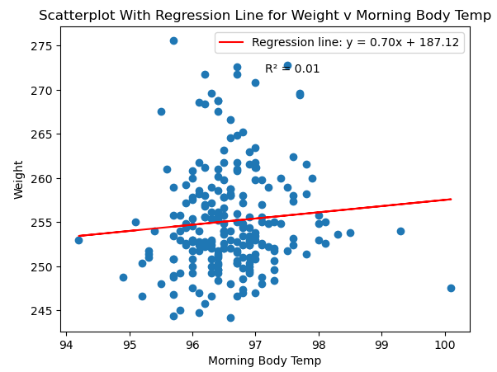

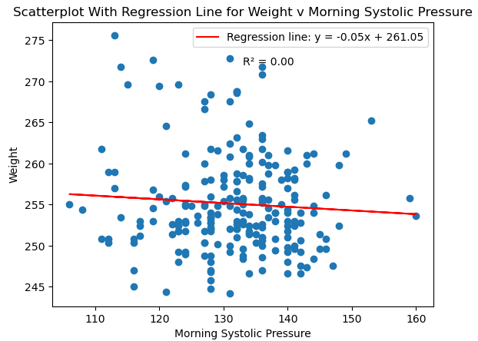

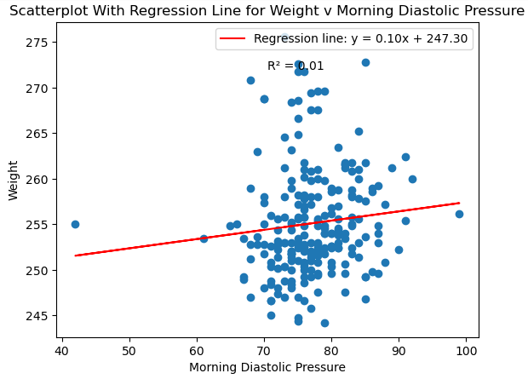

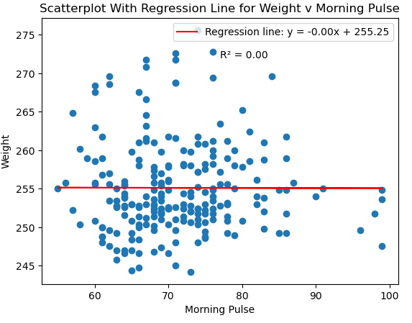

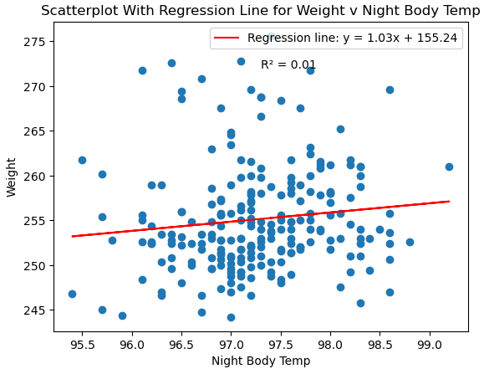

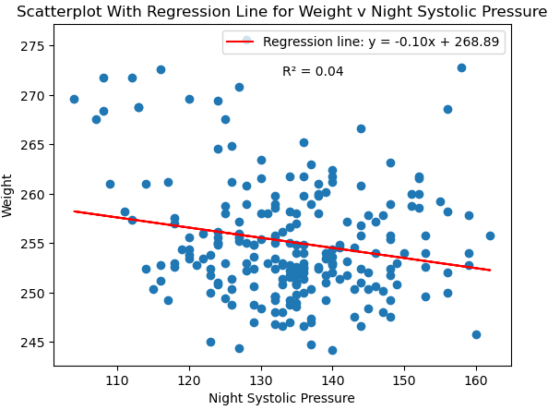

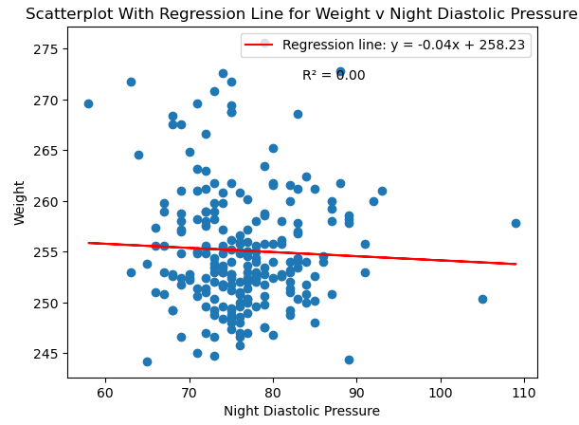

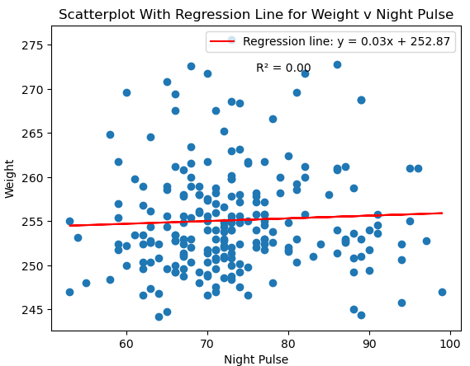

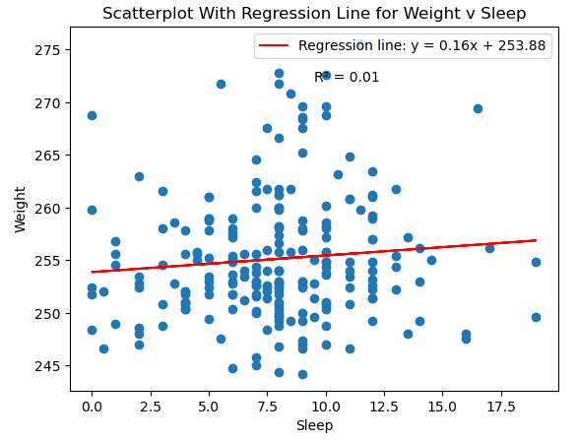

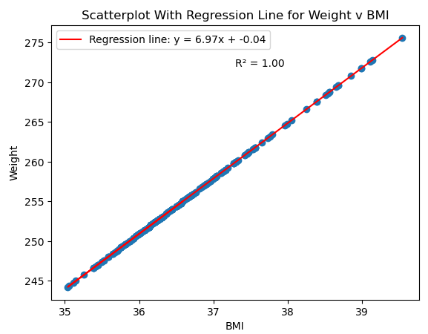

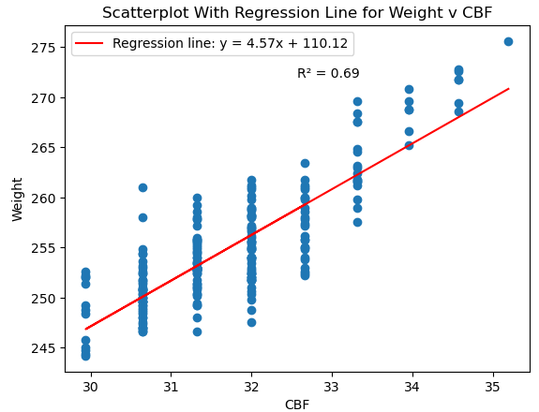

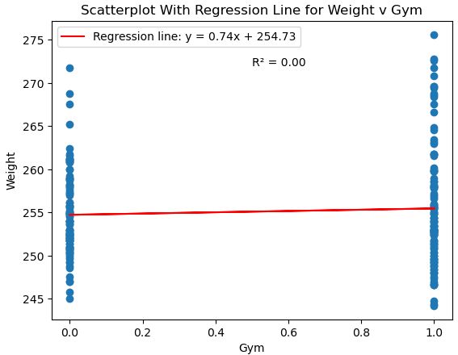

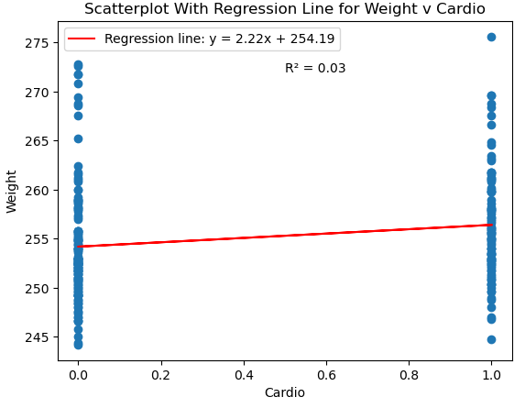

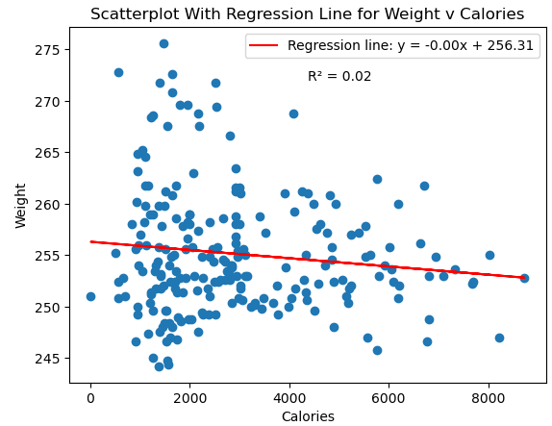

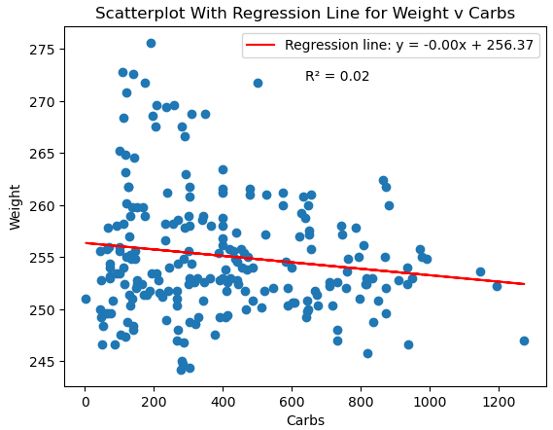

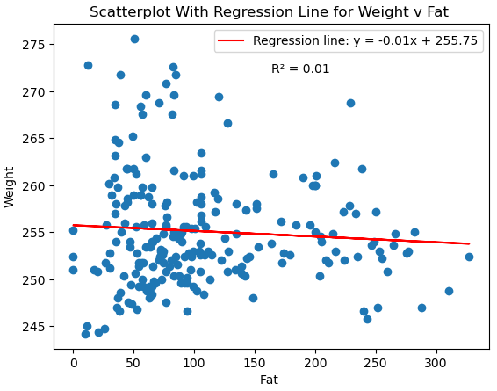

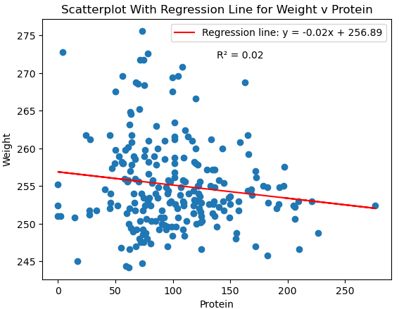

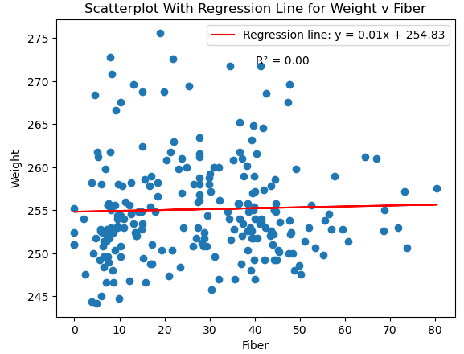

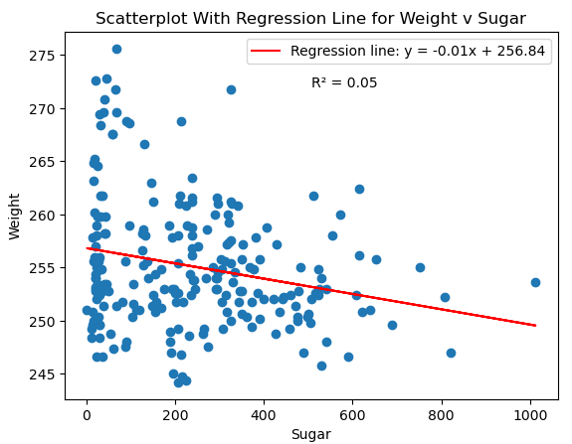

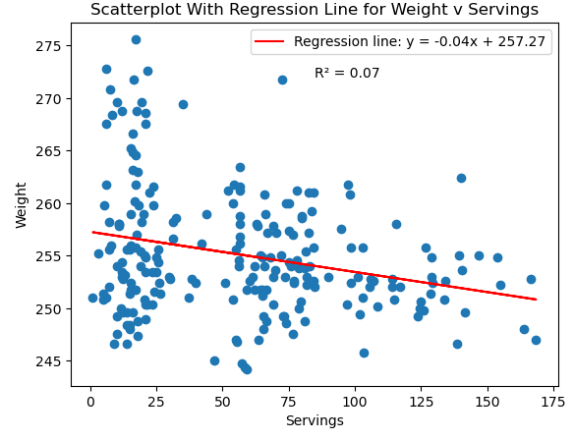

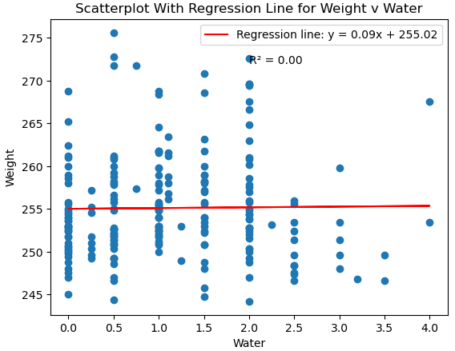

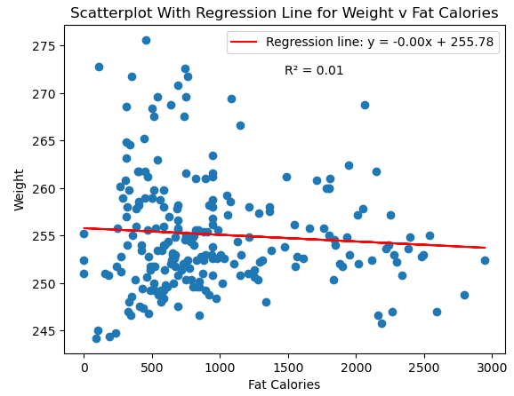

**Graphs 8: Waist Scatterplots with Regression Lines (Python)**

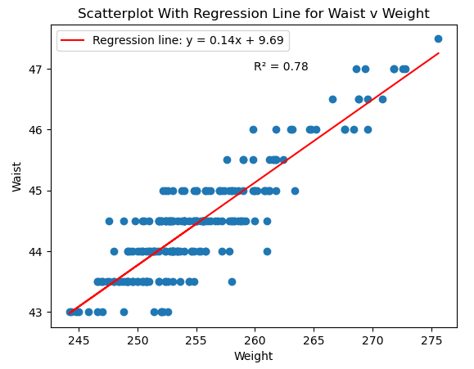

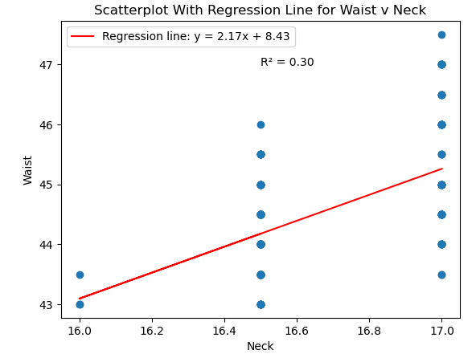

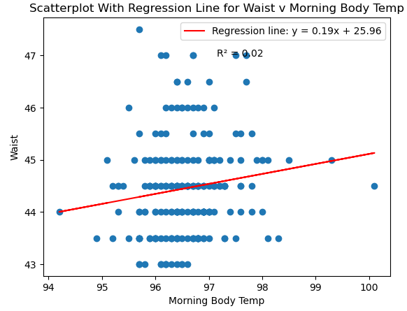

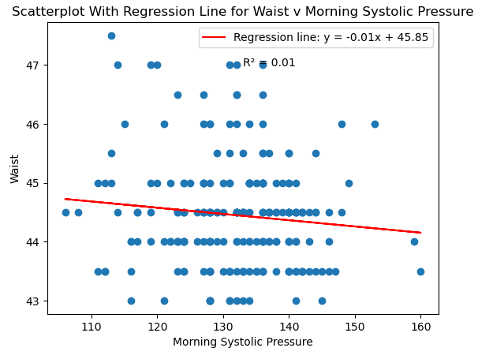

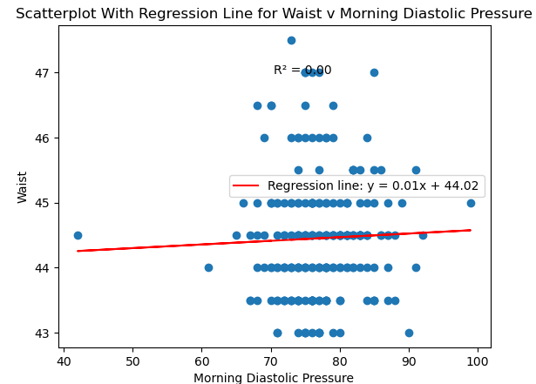

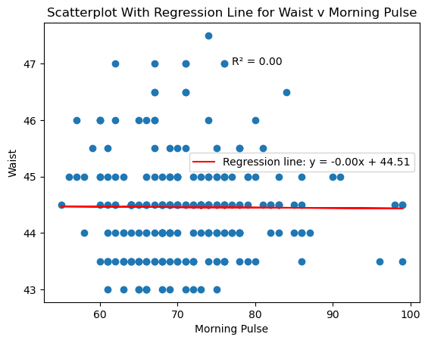

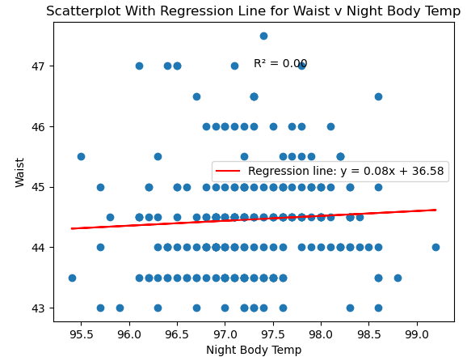

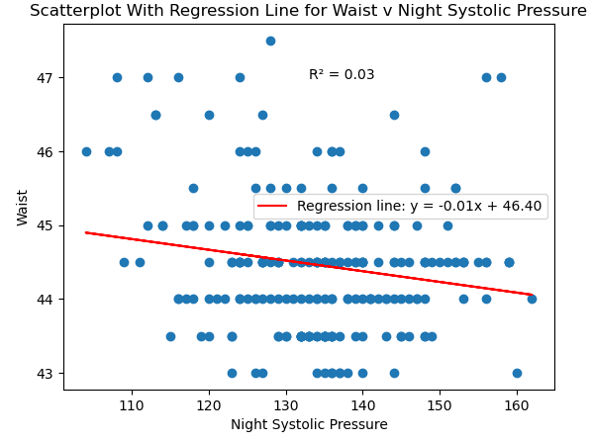

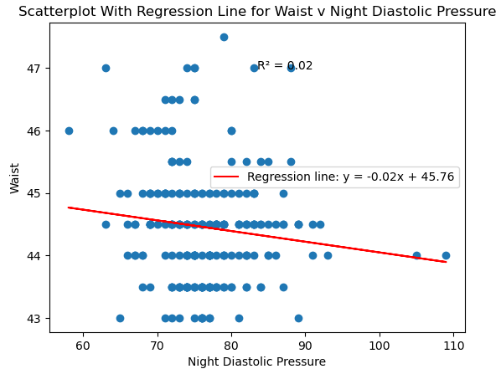

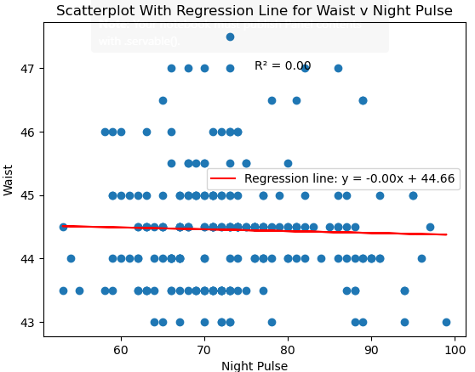

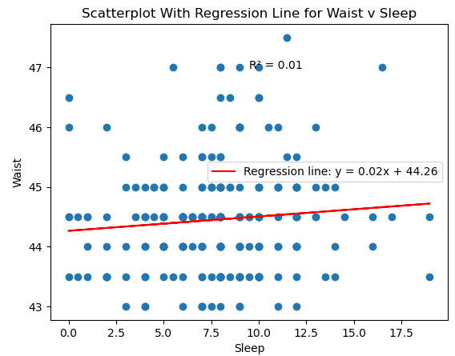

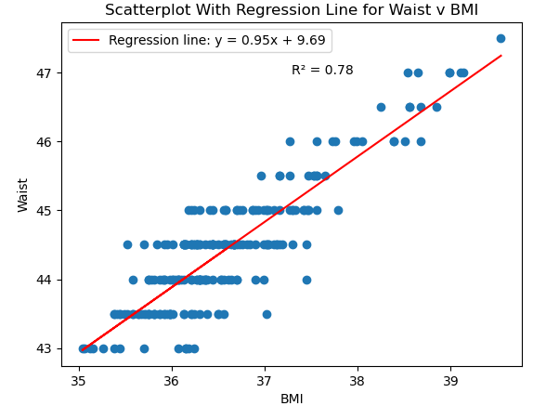

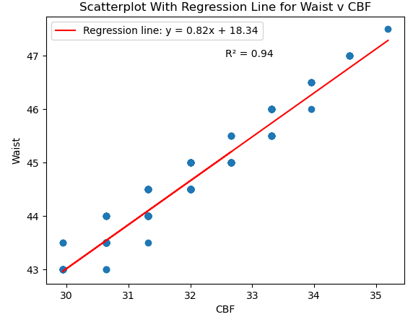

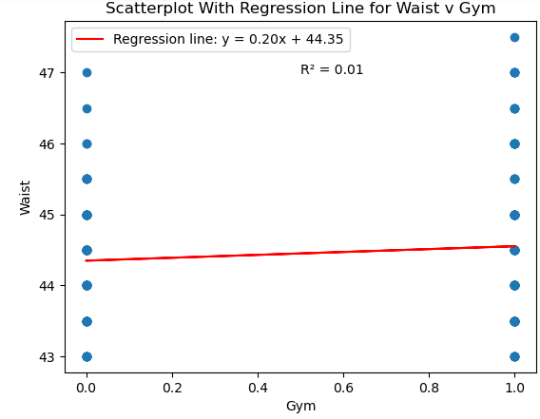

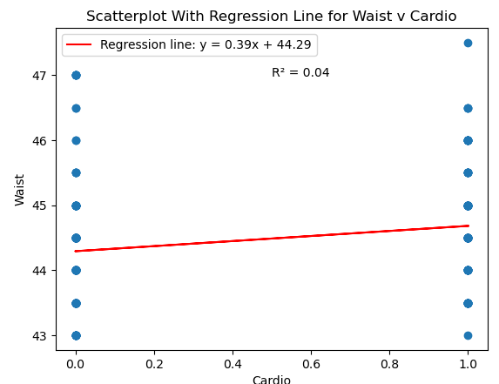

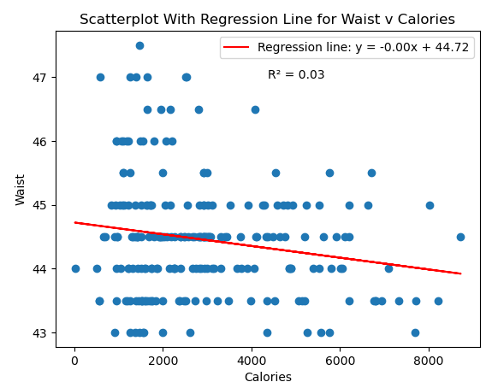

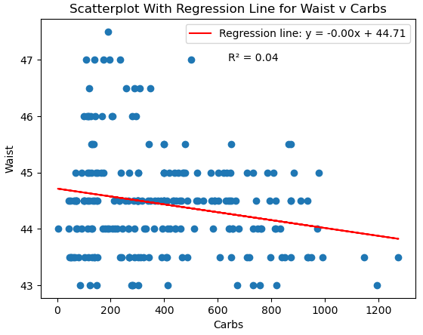

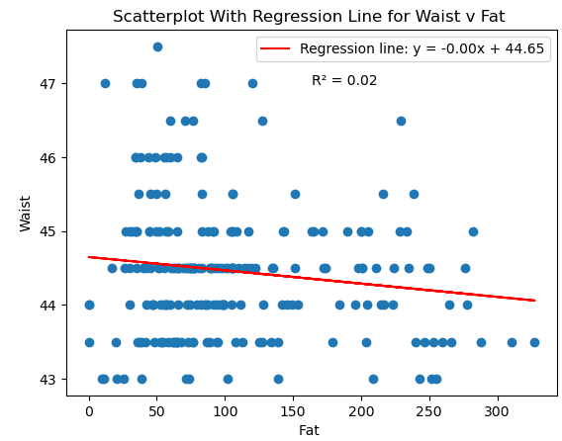

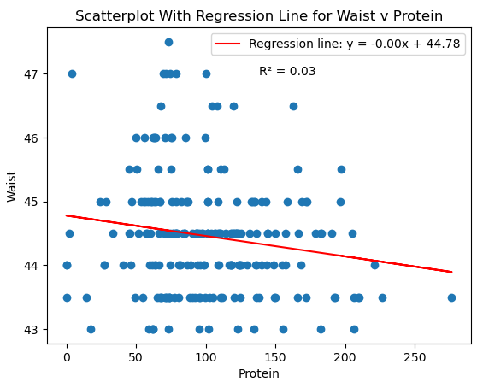

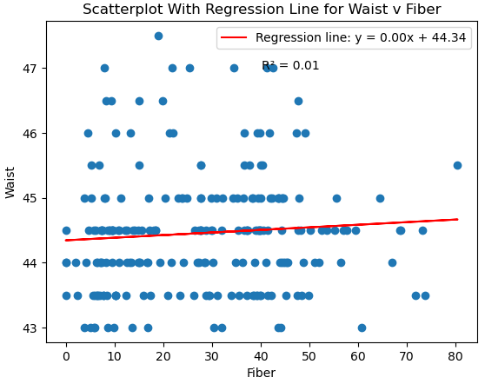

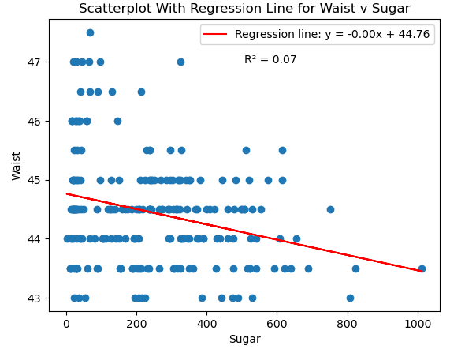

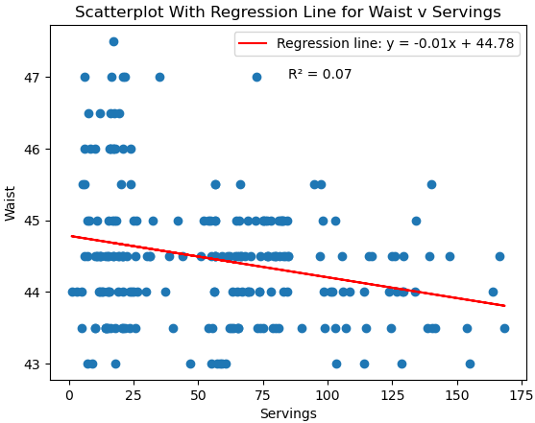

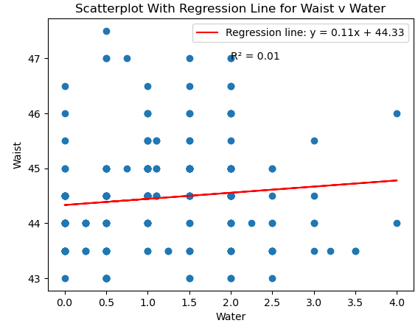

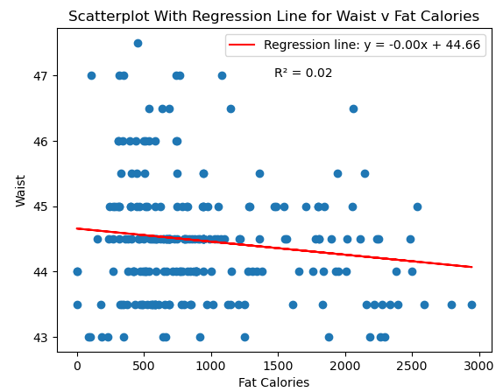

**Graphs 9: Weight Residual Plots (Python)**

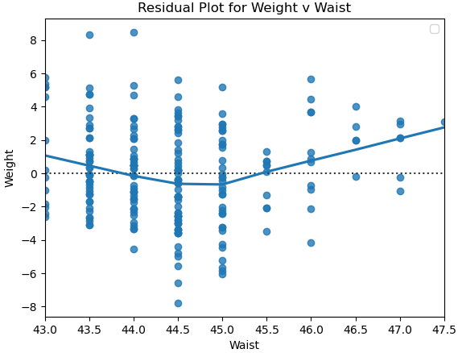

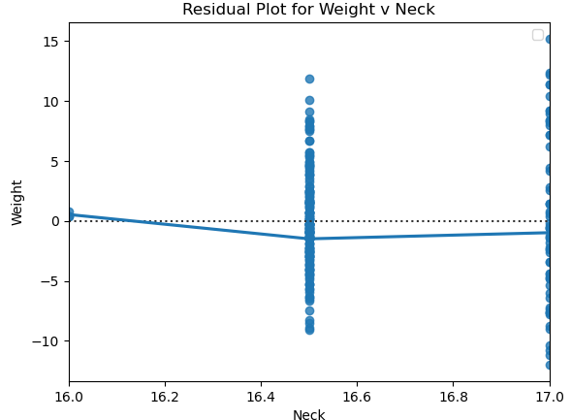

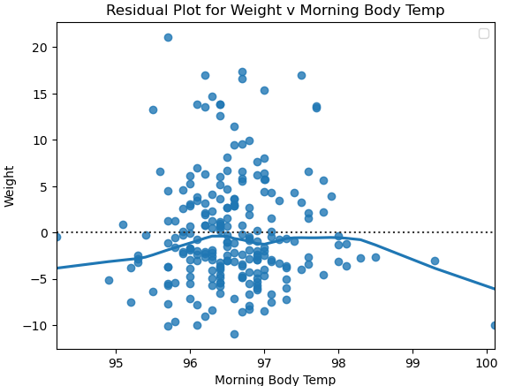

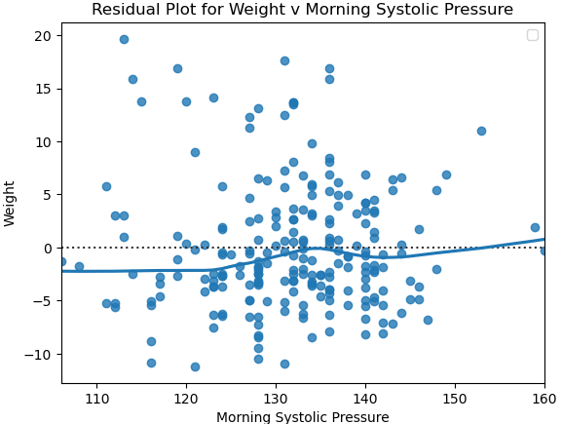

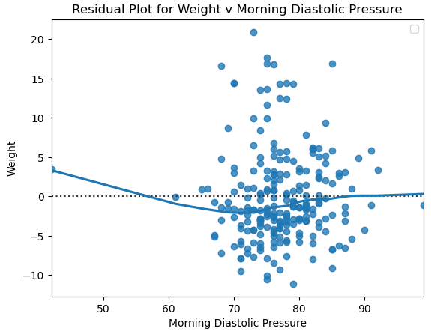

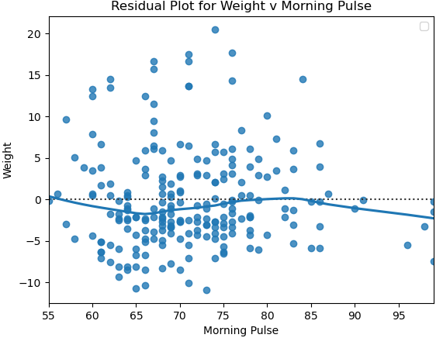

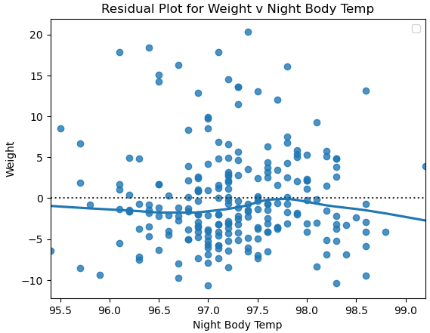

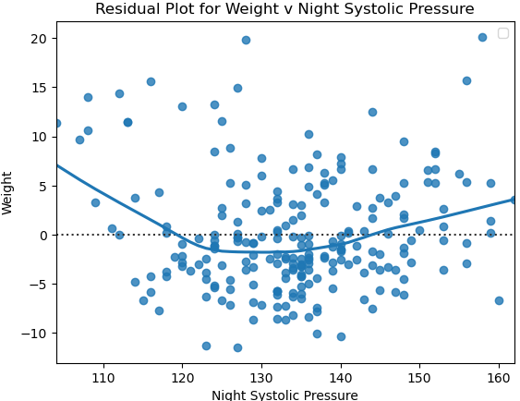

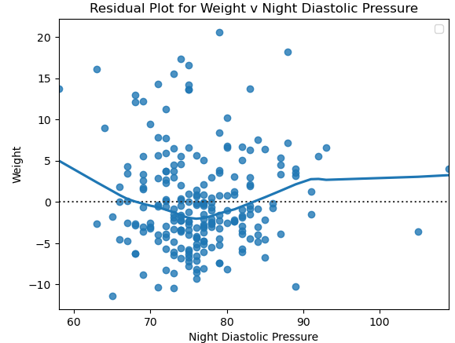

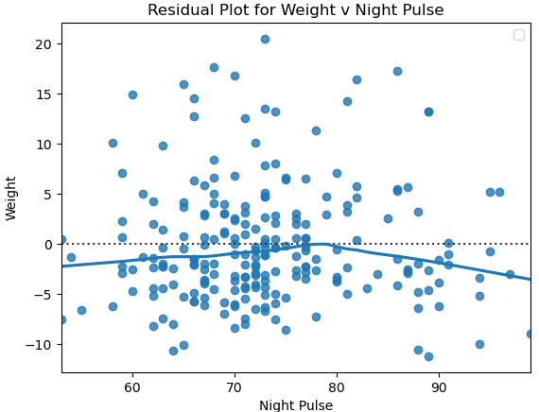

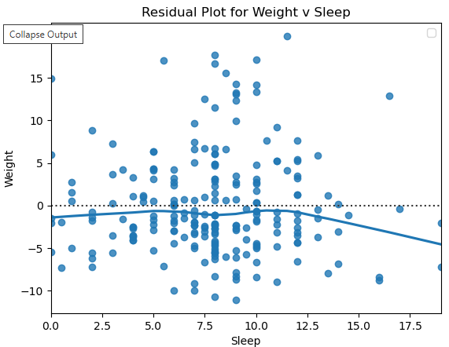

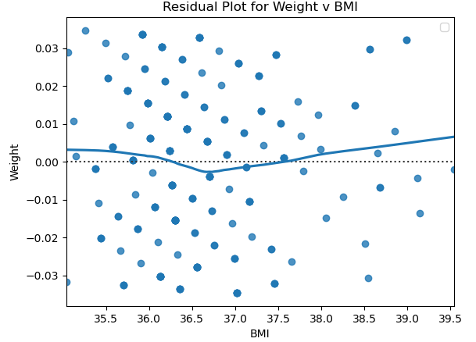

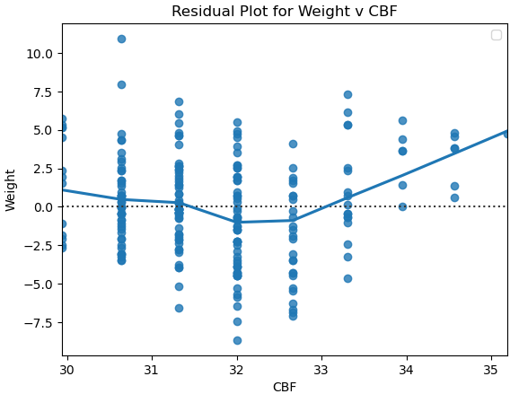

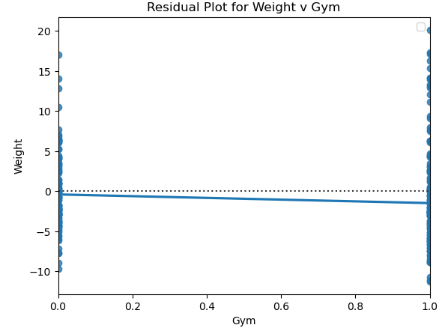

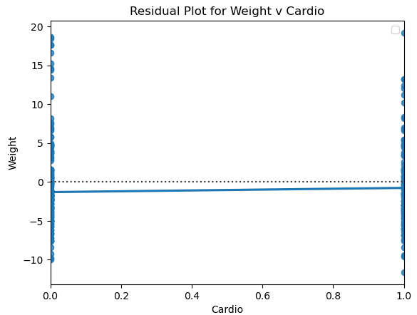

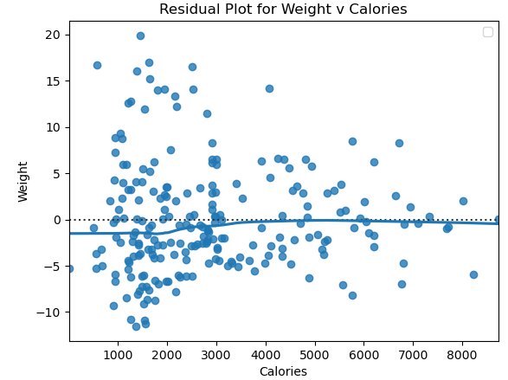

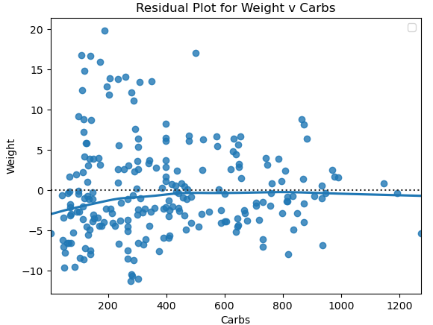

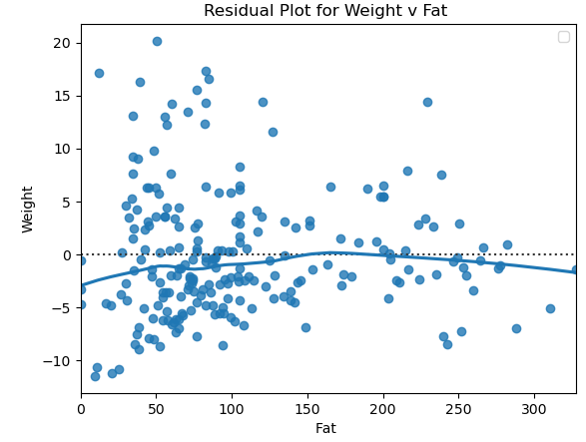

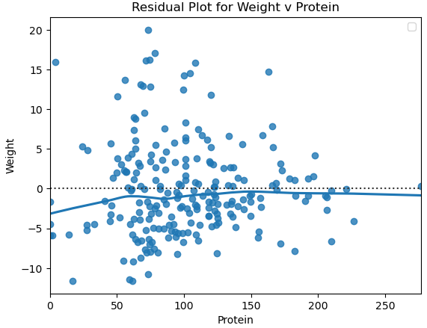

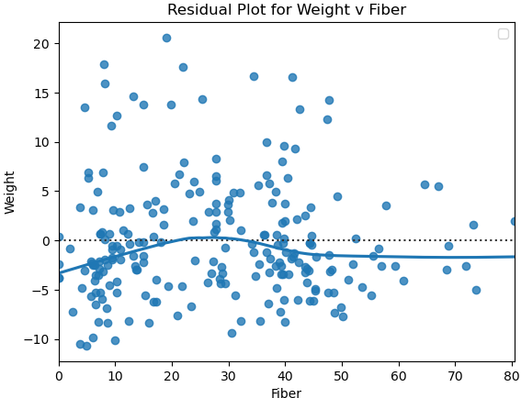

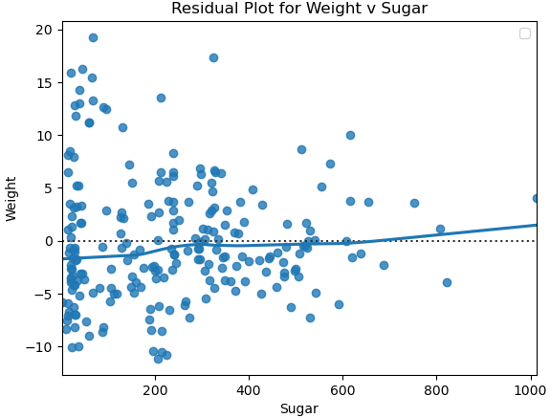

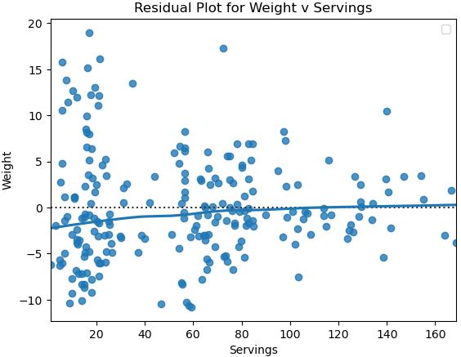

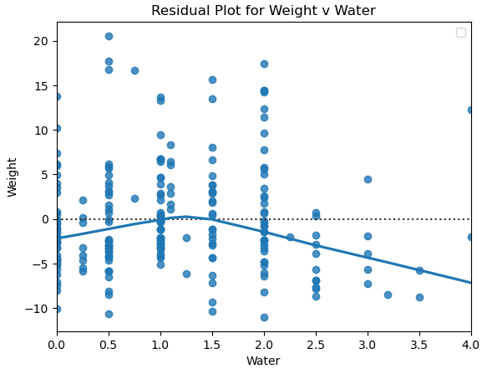

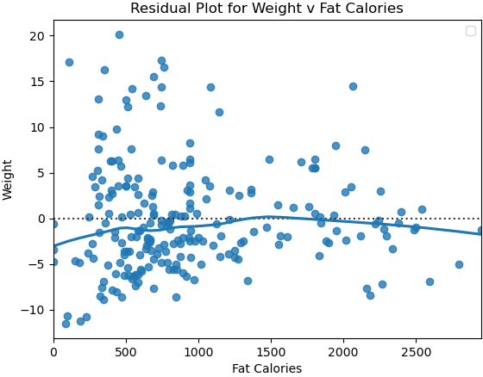

**Graphs 10: Waist Residual Plots (Python)**

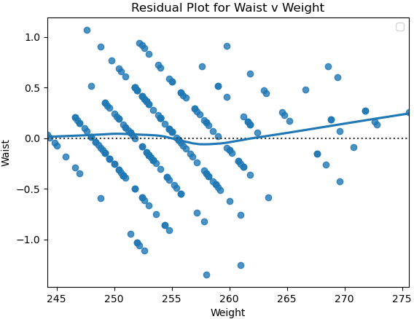

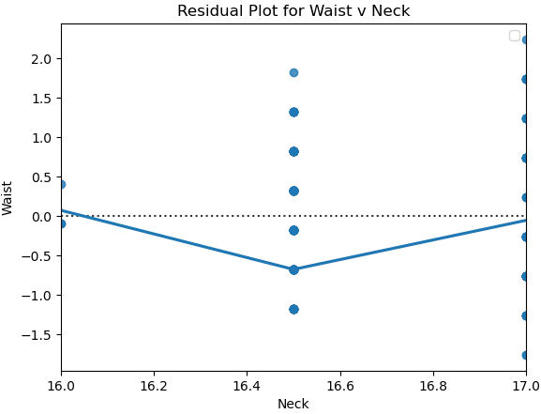

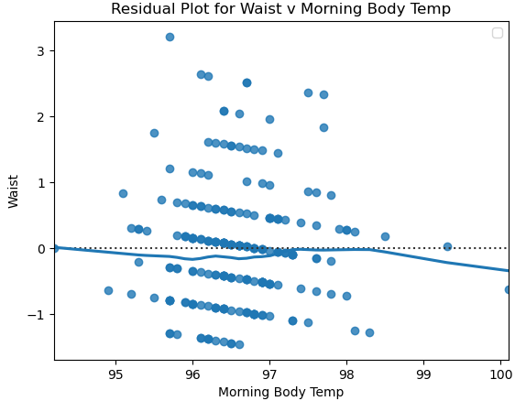

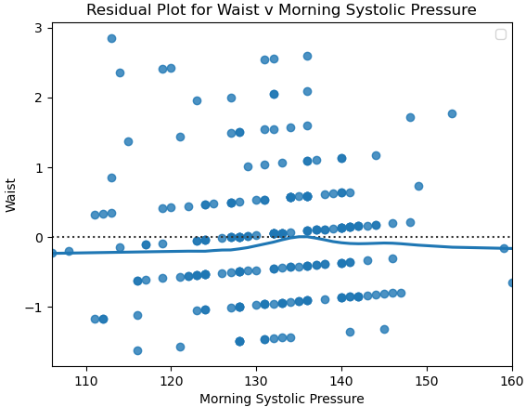

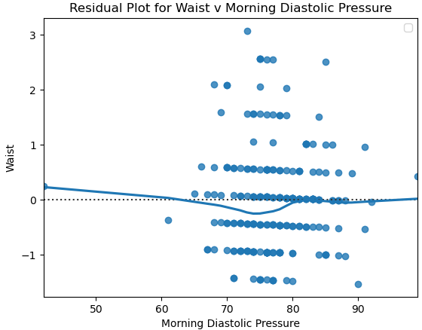

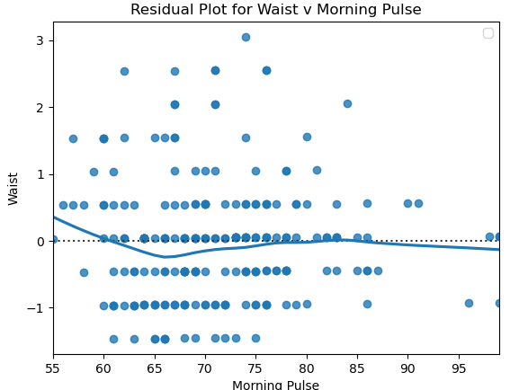

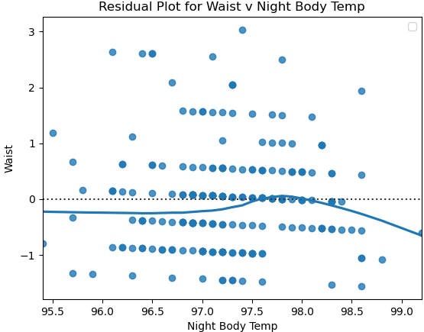

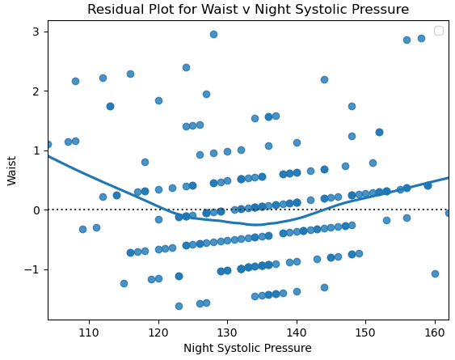

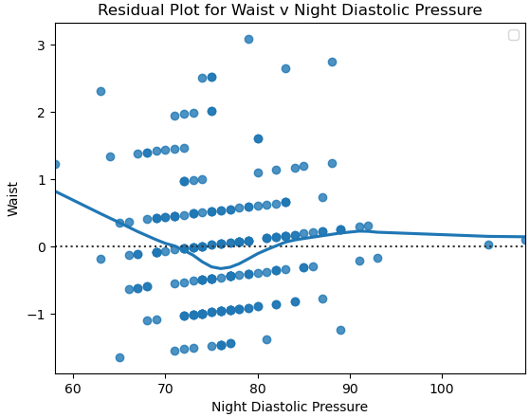

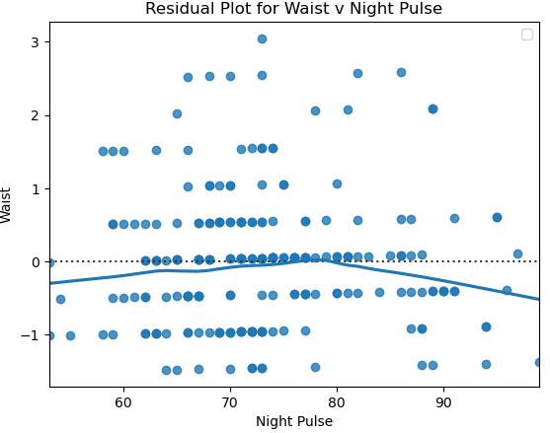

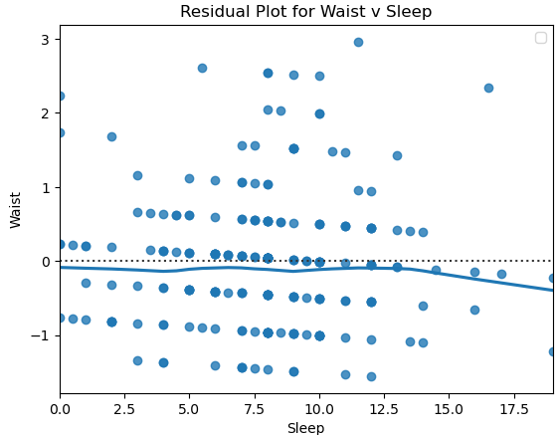

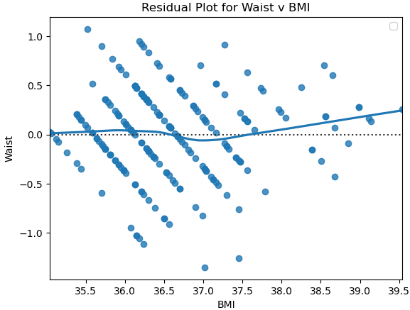

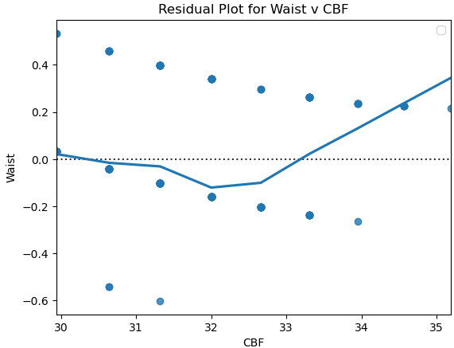

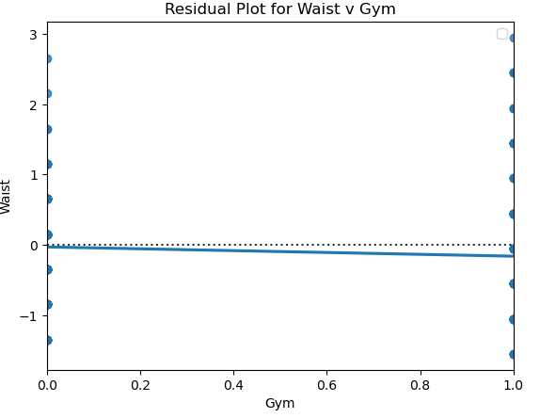

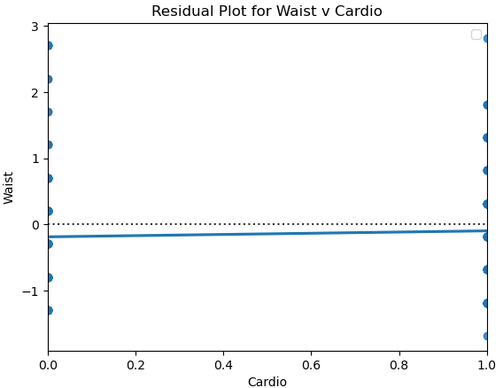

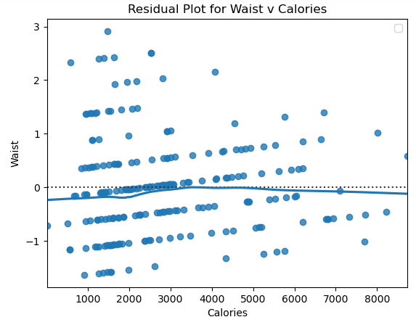

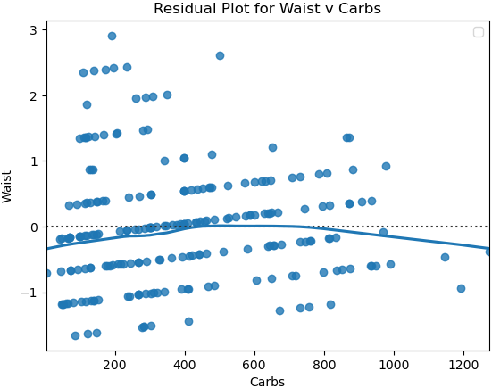

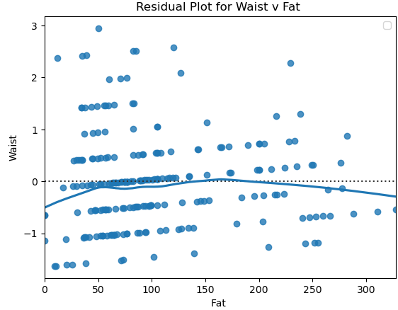

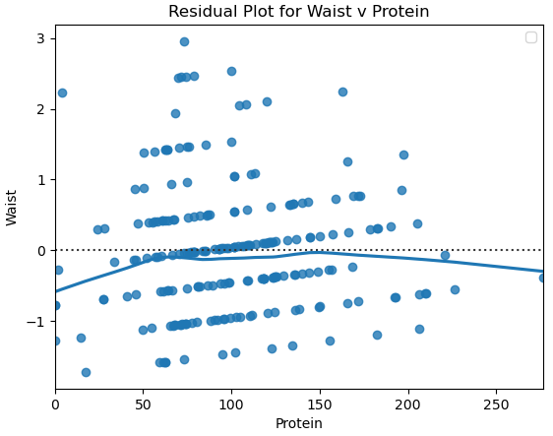

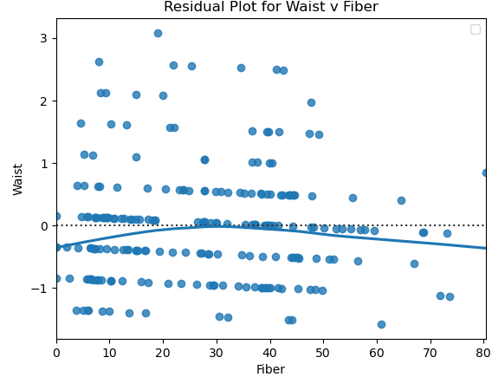

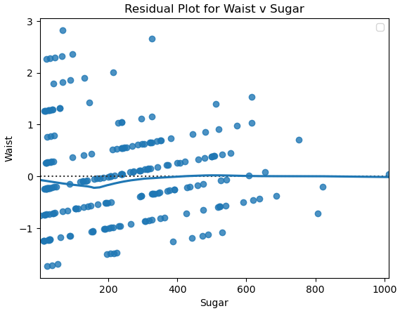

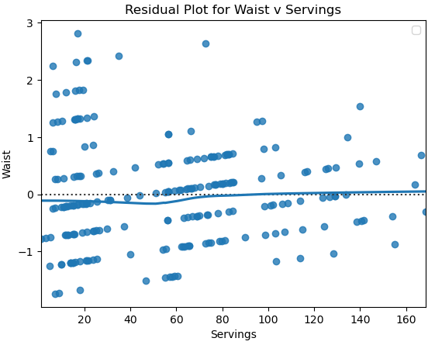

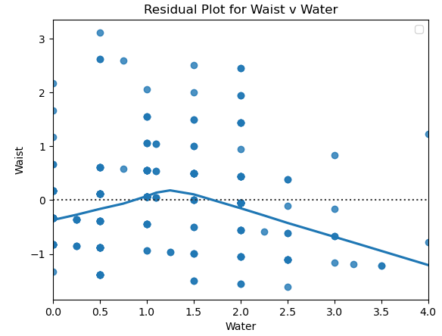

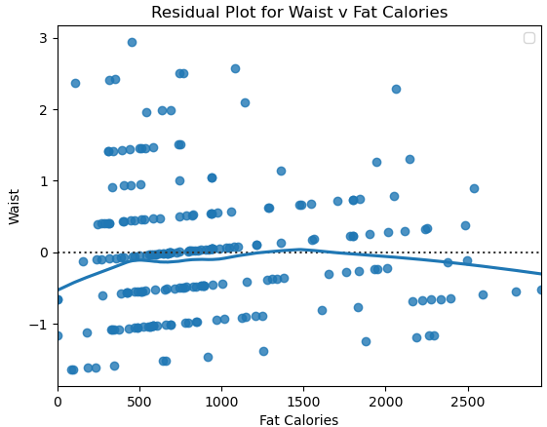

**Graphs 11: Histograms (R)**

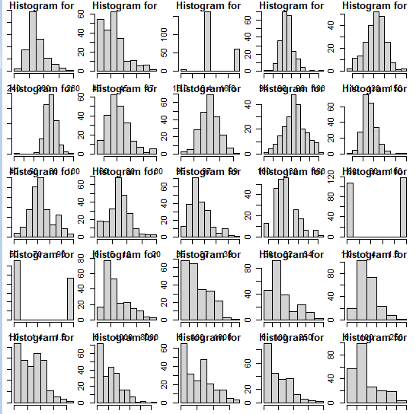

**Graphs 12: Weight Scatterplots With Regression Line (R)**

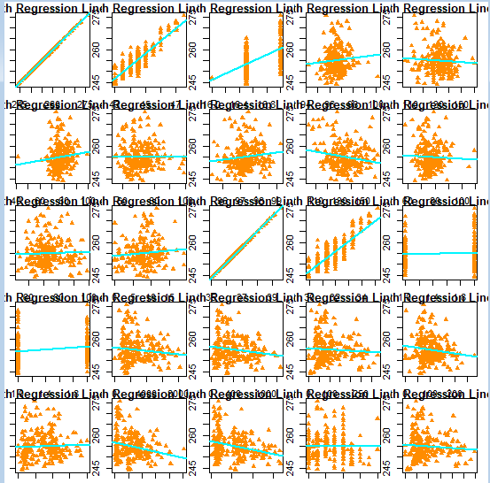

**Graphs 13: Waist Scatterplots With Regression Line (R)**

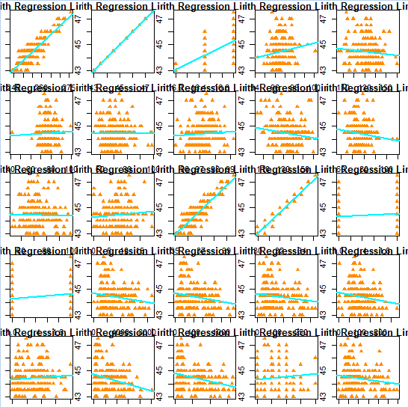

**Graphs 14: Weight Residual Plots (R)**

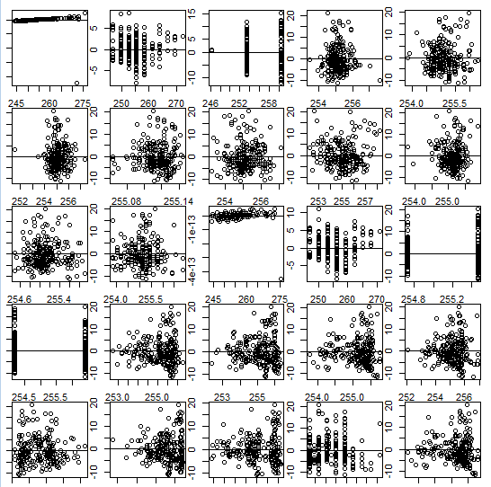

**Graphs 15: Waist Residual Plots (R)**

